**CHAPTER I**

**INTRODUCTION**

The Alumni Career Link: A Smart Tracking System Bridging Graduates and Employment Opportunities is a web application that helps universities to track alumni employment, manage records, and analyze employment trends through graphical data visualization for informed decision-making and planning. It serves as a centralized database that stores alumni records while also connecting graduates with job opportunities to support their professional growth. By strengthening collaboration between universities, alumni, and industry partners, the system supports career growth, enhances alumni engagement, and improves employment prospects. Alumni are the most important parts to an institution's development, representing the school beyond campus. According to Gopakumar, (2023), alumni act as ambassadors, serving as reflection of the quality of education provided through their professionalism evidenced by employment. Engaging with alumni strengthens and improves educational programs and enhances the institution’s reputation.

Educational institutions struggle to maintain alumni connections due to outdated profiles, old contact details make communication and employment tracking tough, and graduates often lose touch due to personal changes or lack of interest. Using digital platforms or web tool can enhance alumni engagement, keep profiles updated, and connect graduates with job opportunities. According to ResearchGate study (2023) supports this, advocating digital platforms for mentorship and job placement to reconnect students, alumni, and industry, improving employability and institutional ties.

The development of the Alumni Career Link: A Smart Tracking System Bridging Graduates and Employment Opportunities is to keep in touch with the graduates, and aid the alumni searches to identify whether graduates are employed or not. As stated by MihirJayavant (2018), the alumni tracking system web-based application helps to track former students which can improve the tracking of graduates in a modernize way, making it more advanced and faster in tracking of alumni. It can aid in providing alumni data or information to college faculties, which eventually makes the overall process more efficient.

The system can be used as a reliable and convenient system wherein, the school institution tracking alumni information seems a burden especially when it comes to track the employment status of graduates. It aims to establish a web application that effectively engage with the graduates and keeps alumni records. Thus, develop a communication among alumni which leads to have a better network to the institution. Moreover, this web application will enable graduates to maintain communication and stay updated on group discussions or job postings.

**Problem Statement**

Administrators find it hard to track alumni employment status because of the outdated information and many graduates don’t respond to requests for updates. A 2024 study confirms this, noting that low survey response leaves universities with incomplete job data, hindering efforts to monitor graduate outcomes (Johns Hopkins Bloomberg School of Public Health, 2024). The lack of responsiveness from certain alumni to administrative notifications asking for the latest information on graduates’ employment status, making it difficult for the administration to stay informed about the graduates’ employment status. Specifically, the present study seeks to answer the following questions.

1. What is the current process used by the Research Office of the university

in terms of managing its alumni’s employability data and records?

2. What is the level of difficulty encountered by Central Philippines State University Planning Office San Carlos campus in terms of;

a. Maintain an updated alumni record

b. Verifying employment information

c. Analyzing employment trends accurately

d. Addressing low response rates to tracer studies

3. What are the technical requirements needed in the development of an Alumni Career Link: A Smart Tracking System Bridging Graduates and Employment Opportunities?

4. How efficient and usable is the development of Alumni Career Link: A Smart Tracking System Bridging Graduates and Employment Opportunities for Central Philippines State University?

**Objectives**

The project aims to increase alumni engagement, intellectual and human

resources according to Tulankar et al. (2020), as alumni sustaining schools through donations and voluntary efforts. By implementing the system, it focusses on alumni records to keep all the alumni information in easiest way, better communication to stay in touch with the alumni and determine the employment status while saving time for manual data entry. The system will allow the university to trace alumni information and can be monitor employability. Alumni can also interact with the potential employers and post multiple jobs to help alumni find employment in their specific skills or in their field of study.

Specifically, this project aims to:

1. To create an application to assess the university in managing alumni employability data, including maintaining records, verifying employment information, analyzing employment trends, and improving response rates to tracer studies.
2. To develop an application that will effectively store, monitor, and manage alumni employment records.
3. To consolidate all the collected alumni employability data and presents it through graphical charts to support decision-making and university planning.
4. To provide a centralized repository of alumni employment records that ensures data accuracy, allows efficient access for university personnel, and supports long-term tracking of graduates’ career progress.
5. To facilitate career services for alumni by connecting graduates with employment opportunities and strengthening collaboration between the university.

**Significance of the Study**

The result of the study will help the university to stay connected with its alumni and intended to improve the tracker system of the school. It saves time and efforts of the school to track the alumni. This project study will benefit the following.

**To the CPSU San Carlos Campus Administration.** This study will help university administrations especially the Research Office in tracking alumni whereabouts and can easily informed if there's a school related event. This can also benefit the university for its future decision making and strategic planning.

**To the Alumni.** Former students can easily access of job opportunities and find employment. This ease of access encourages alumni to update their account to stay informed about relevant news.

**To the CPSU San Carlos Campus.** This study will help San Carlos campus to have a diverse way to track the alumni information and determine the employment status which can lessen their workload or manual data entry.

**To the Future Researchers.** This study will serve as relative information for other researchers and can serve as basis in developing their own web applications and tracking system for creating their own version of the Alumni Career Link: A Smart Tracking System Bridging Graduates and Employment Opportunities for future use.

**Scope and Limitations**

The study focuses on developing an application to assist the university in managing alumni employability data by enhancing record-keeping, employment verification, employment trend analysis. The system will serve as a centralized platform for storing, monitoring, tracking and managing alumni employment records while providing graphical analytics to support university planning and decision-making. Additionally, the system aims to connect alumni with job opportunities to find their employment.

This web application will be implemented at CPSU San Carlos Campus to assist in tracing the employability of its alumni. However, it will not include alumni records from other CPSU campuses. Employment status updates will be entirely self-reported by alumni, as the system does not have an automated verification process. The accuracy and completeness of employment data will depend on alumni willingness to update their records, and any updates will be at their discretion. Additionally, the system will not detect or prevent falsified information submitted by users. Furthermore, while the platform facilitates job opportunities by connecting alumni with potential employers, and it does not guarantee direct job placements.

**Definition of Terms**

**Alumni Engagement.** In this study, it refers to a feature in the system designed to foster interaction between alumni, universities, and employment opportunities.

**Career Link.** In this study, it refers to graduates or alumni that are connected to potential employers who can post jobs, enabling them to find employment through the system.

**Centralized Database.** In this study,it refers to a storage component of the system where files and data are stored, organized and managed.

**Data Security.** In this study, it refers to measures to protect sensitive data, ensuring access is restricted to authorized users only.

**Graphical Data Visualization.** In this study, it refers to a representation of employment trends and alumni data through charts and graphs to support decision-making and planning for the university.

**Group Chats.**  In this study, it refers to a feature for communication between alumni and school personnel.

**Job Opportunities/Portal.** In this study, it refers to a system feature enabling employers to post job openings and alumni to apply for jobs.

**Real-Time Data Updates.** In this study, it refers to a system’s ability to immediately synchronize and display changes to alumni profiles or job postings.

**Repository.** In this study, it refers to a central location where all resources are stored and managed.

**Tracer Study.** In this study, it refers to a method of collecting data on alumni to assess their employment status and outcomes, used to evaluate institutional performance.

**Tracker.** In this study,it refers to alumni information used to determine their employment status.

**User Authentication.** In this study, it refers to a secure login to verify user identities (e.g., admins, alumni, employers).

**Users.** In this study, it refers to a person who uses and interacts with the system.

**Web Application.** In this study, it refers to the network connections that enable users to access and utilize the system.

**CHAPTER II**

**REVIEW OF RELATED LITERATURES AND SYSTEMS**

This chapter provides a review of related literature and studies that will help the researchers gather basic data and references for the current study. Important facts were provided by the researchers that presents a comprehensive summary of existing research and studies to support the significance and relevance of the Alumni Career Link: A Smart Tracking System Bridging Graduates and Employment Opportunities’ creation.

**Foreign Literature**

According to the Thomas et al. (2019), graduate is one of the important supports in the development of a university. Graduate have a role to assist universities in developing the university into the community through collaboration in academic terms which also stated by Anggraeeny et al. (2020), the alumni are the representatives of the institution's quality, greatly influence community perceptions and school choices. The study explores alumni contributions to extracurricular activities, advocacy for school quality, networking, mentoring, event support, and curriculum evaluation and observation. In relation, the study highlights how important role of alumni in educational institutions. The proponent used this as a basis in implementing an alumni tracking system that can enhance the school institution's visibility and reputation, ultimately contributing to its growth and success while giving an opportunity to alumni to have a career progress.

This study presented by Yuniarto et al. (2020), that the use of Information Systems for Alumni Tracking has become a major dilemma. But the Tracer Study Information Systems in private higher education found that the system is not fully effective yet an unable to provide satisfactory solutions for alumni tracking. The purpose of this study is to determine the success of using tracer study. Similarly, Safi’I et al. (2019), one way to find out the condition of alumni is to do a tracer study. Tracer study or alumni tracking is information gathering activities of alumni regarding the competencies needed by stakeholders as material for the process of improving education. It serves as a valuable reference for the researcher’s system to focus on developing or improving an alumni tracking system with job opportunities to better serve the needs of both the institution and its alumni.

Based on the study of Hasibuan et al. (2022), the study emphasizes the role of alumni in evaluating teaching quality at Medan State University. They conducted a study using surveys and data analysis to assess alumni skills and job status. Findings indicated that graduates were well-prepared for jobs, quickly found employment, and satisfied their employers. This study highlights the importance of understanding alumni outcomes for improving educational programs. The proponent used this as a basis to develop a system that consolidate all information of former students in CPSU San Carlos campus to determine graduates career paths after leaving the university.

This study stated by Akbar et al. (2022), that the socialization of e-tracer study for college of alumni aimed to educate alumni about the significance of mapping graduates as a quality measurement standard for universities. In relation of the Alumni Career Link: A Smart Tracking System Bridging Graduates and Employment Opportunities is to facilitate a communication platform to have a better engagement of alumni, such as group chats to inform alumni about upcoming school activities or other related school activities.

Based on the study of Setyaningsih et al. (2022), the study aimed to improve higher education management. The university's Alumni Bureau requiring effective communication management. The study identified a communication management model comprising adjustment, communication planning, action, and evaluation at boarding university. It somehow related to the researchers’ system because it aims to enhance how universities interact with alumni and manage the information. The researchers seek to make tracer studies more effective in engaging alumni and collecting data, which aligns with the goal of the proponent system to create a platform for alumni information and communication, to track their employment status while providing opportunities to help graduates find employment.

According to Sampun (2022), conducted at the State University of Surabaya aims to identify and understand the satisfaction levels of graduates who participated in the PPG program from 2018 to 2020. By using interviews and questionnaires which is manual methods to collect a data from PPG graduates in the Madiun, Ngawi, and Magetan areas, as well as from the principals of schools where these graduates teach. The researchers used this study served as a basis for developing a system to improve data collection efficiency, enabling automated data gathering and sustained communication with graduates without relying on manual methods.

In this literature study presented by Verified Market Reports (2023), that relevant to the Alumni Career Link system, as it discusses the trends of alumni tracking systems, focusing on their role in fostering engagement, tracking employment outcomes, and supporting institutional goals. The emphasis on connecting alumni with career opportunities and improving data management aligns with the Alumni Career Link system that centralized database and job portal features. The study’s perspective, including insights from foreign markets, complements the international applicability of alumni tracking systems, while its focus on market trends and stakeholder benefits (e.g., employability, networking) supports the system.

In this study explained by Mijic et al. (2019) that directly relevant to the Alumni Career Link system, as it addresses the core goal of tracking alumni to monitor employment outcomes and improve institutional programs. The emphasis on web-based data collection and stakeholder engagement aligns the Alumni Career Link system’s as it is a centralized database and job portal to connect graduates with employment opportunities. The study’s focus on employment data and curriculum alignment supports the Alumni Career Link system’s objective of bridging graduates with career opportunities, while its discussion of quality assurance aligns with the use of tracer studies to evaluate institutional performance.

**Local Literature**

Based on the study of Tayco et al. (2022), the study found that most alumni are employed in fields related to their degrees, with the majority working locally in roles aligned with their college courses. This study served as a basis of proponents for developing a web application to track alumni employment status and assess job alignment with their degrees efficiently. Similarly, Pentang et al. (2022) reported that many graduates are employed in roles related to their academic programs, reinforcing the importance of job alignment. These findings highlight the need for universities to maintain connections with alumni and track their employment outcomes, which informed the development of a system to monitor the employment status and job alignment of CPSU graduates.

According to Kalaw (2020), the presented tracer study aims to determine the graduates' employability and academic skills. The researchers used this study as a basis to improve university alumni tracking by determining the employment status and job alignment. In accordance of Evan. (2021), the study aimed to document the graduates' profiles, the alignment between their courses and employment. The study served as a basis of proponents to develop a system to track employment status and determine if graduates’ careers align with their degrees. By collecting data on job outcomes, the system enables administrators to monitor alumni.

This study presented by Lopena et al. (2023) and Abulencia et al., (2021) highlighted the role of employment outcomes in reflecting institutional quality, noting that graduates’ performance and satisfaction with their education enhance university reputation. The proponent system which is an Alumni Career Link system builds on this by connecting alumni with employers through job opportunities, thereby strengthening institutional visibility as graduates succeed in their fields.

Based on the study presented by Penera et al. (2021), found that the majority of graduates from Cebu Technological University-Daanbantayan Campus are employed with permanent status. This study served as the basis for the researcher to recognize the importance of an alumni tracking system in assessing employability and determining the university’s contribution to graduates’ success. Universities should not only demonstrate their role in helping graduates secure employment but also actively provide job opportunities for alumni. Such efforts create opportunities to support alumni in finding employment.

According to Dela Cruz (2022), the tracer study of Graduate School about graduates’ profiles, employment status and employability characteristics identify that graduates of State Higher Education Institution in the Philippines have a very high employability rate based on the result of descriptive statistics used to analyzed the data of graduates. The study served as the basis of the researchers to create a system that strengthen a connection with alumni and track their employment status to analyze the employment trends.

The studies by Torres et al. (2021) and Patulin et al. (2024) both highlight the importance of having a system to track alumni and support them after graduation. Torres et al. (2021) focused on helping PUP–San Pedro know where the graduates are and if the courses were useful in getting jobs. On the other hand, a tracer study of Patulin et al. (2024), graduates from the College of Teacher Education and Graduate School at Surigao del Norte State University aimed to assess the employment outcomes, job satisfaction, and the relevance of the education received. The findings revealed that a significant majority of graduates were employed in permanent positions, with many working in government institutions such as the Department of Education. In relation, the value of systematic tracking of alumni is to assess the effectiveness of educational programs. The insights gained from such studies can inform curriculum development and improve alumni engagement strategies.

**Foreign System**

As explained by MihirJayavant (2018), Alumni Tracking System is an online-based application that helps to enhance the tracking of college graduates and provides alumni data to college faculties. It aims at developing a mobile application and web portal which will be useful for the college to monitor the alumni's and for the alumni to update their current status and get notified about the college activities which also stated by Bista et al. (2021), the alumni portal and tracking system integrates and manages alumni data, providing a portal for alumni to update their information. Both systems are enhancing alumni engagement, improves data management, and aids in understanding alumni trajectories. In relation, the proponent system aims to have an alumni engagement that provides a job portal for alumni to find their employment and can update their information making it easier to collect and update alumni. The proponent system is also a web-based application to develop communication between graduates and the institution, where administrators of the school can communicate with alumni, enhances alumni engagement and update current status. In accordance of Suresh et al. (2020), this system is a platform were enabling them to connect and stay updated.

Based on the study of Sadi et al. (2020). the development of the technology has become increasingly rapid with almost everyone currently having a handphone. With the widespread use of Android smartphones, presenting an opportunity for institutional development especially in tracking alumni. To address this, Sadi et al. (2020), developed an Android app to track alumni includes maintaining updated contact information, tracking career progress, and facilitating communication between alumni and the institution. This system is similar to the researchers’ system which is to track former students and enhance institution's ability to stay connected with its graduates and supports alumni networking with career services using technology.

As indicated in Sucipto et al. (2020), the system collects data, accessibility, communication, usability, and overall performance in assessing alumni achievements in Vocational Schools in Kediri. In relation, the proponent system aims to improves communication between schools and alumni. By collecting the data on graduates according to Yunanto et al. (2021), the system provides valuable feedback for improving the education process, curriculum and student activities, improving the quality of graduates and enhancing the education process. Additionally, making it more effective to track alumni and monitor the achievements and progress of the graduates.

This study presented by Kumar et al. *(*2023), as developed a Secured Web-based Alumni Network and Information System that facilitates communication, promotes career advancement, fosters mentorship, and ensures data security. The system strengthens relationships between colleges and alumni while benefiting current students by connecting them to opportunities such as placements, internships, and workshops. Features include alumni registration, interfaces to share job opportunities, mentorship programs, and platforms to highlight alumni achievements, all designed to inspire students and enhance career paths. This study emphasizes the importance of maintaining connections with graduates through a comprehensive online application to support institutional engagement and professional growth. In relation to the Alumni Career Link: A Smart Tracking System Bridging Graduates and Employment Opportunities, this study supports the development of a platform that maintains alumni connections, facilitates communication through features like group chats, and provides job opportunities to enhance employability.

**Local System**

This study presented by Arbaja et al. (2023), developed an internet-based system to effectively track, manage, and analyze alumni data, enabling institutions to monitor employment status, work alignment, and job whereabouts of ACI graduates. The system facilitates a high rate of data collection, contributing to improved educational strategies and outcomes. In relation to the Alumni Career Link: A Smart Tracking System Bridging Graduates and Employment Opportunities, this study supports the development of a platform that tracks alumni employment status, collects comprehensive employment data, and manages information to enhance institutional engagement and graduate success.

This study presented by Wenceslao (2022), developed an App-based Alumni Tracer System with Statistical Support to enhance communication between alumni and their institutions using web and mobile technologies. The system maintains connections, monitors employment status, and manages alumni data through user-friendly web and mobile interfaces. In relation to the Alumni Career Link: A Smart Tracking System Bridging Graduates and Employment Opportunities, this study supports the development of a platform that fosters alumni engagement, manages comprehensive graduate data, and tracks employment outcomes. By implementing such a system, universities can efficiently monitor alumni data to support institutional goals and graduate success.

This study presented by Cinco and Dalan (2019), developed a Web-based Alumni Network and Database Information System with a Mobile Application to facilitate alumni networking and data management using web and mobile technologies. The system enables alumni to build networks through web and mobile interfaces, storing their information in a database for institutional purposes, such as tracking and engagement. In relation to the Alumni Career Link: A Smart Tracking System Bridging Graduates and Employment Opportunities, this study informed the development of a platform that tracks alumni, fosters effective connections, manages graduate data, and keeps alumni updated with institutional news to enhance engagement.

This study presented by Trinidad (2023) developed a web-based alumni tracing and job search system for CTU Naga Extension Campus to track and monitor alumni records, provide easy access to graduate information, and offer relevant job opportunities. The system helps alumni find employment that aligns with their skills, enhancing their career prospects post-graduation. In relation to the Alumni Career Link: A Smart Tracking System Bridging Graduates and Employment Opportunities, this study supports the development of a platform that monitors and tracks alumni employment status, manages graduate data, and provides job opportunities to foster alumni success and institutional engagement.

As explained by Joery et al. (2023), the Online Monitoring and Tracking System for Dormitoryaims to provide a centralized platform. This system is used to enhance student monitoring which also related to the system of Borlio et al., (2021), aimed to create a tracking system to monitor the current location of visitors or students inside the University. In relation of Capili-Kummer et al. (2021) system, was developed to centralized a platform for alumni monitoring to gather up-to-date information of graduate’s employment status and maintaining alumni information using web-based system. Then send notifications through alumni registered email address. The proponent’s system is somehow related to this system that also a platform to maintain alumni information. It enhances alumni communication, interactions between alumni and the university, track whereabouts and employability.

**CHAPTER III**

**METHODOLOGY**

This chapter presents the methodology that will be used in this project, providing a detailed explanation of the design method, and discussing each phase of the chosen model. The flow of the study will also be explained as well as functional and non-functional requirements, system workflow, flowchart, system architecture, and diagrams. Additionally, this section will describe the environment of the study, the instrument and data gathering procedure.

1. **Design Method**

The proponent uses an agile, user-focused development approach that values flexibility, iterative progress, and continuous feedback over planning. Agile promotes frequent testing and releases, with less emphasis on extensive documentation-focusing instead on essential records that support collaboration and development-aiming to efficiently produce high quality software that meets user needs. This approach allows teams to quickly adapt to changes and continuously improve the product based on user input. As a result, the final software is more aligned with user expectations and real-world requirements.

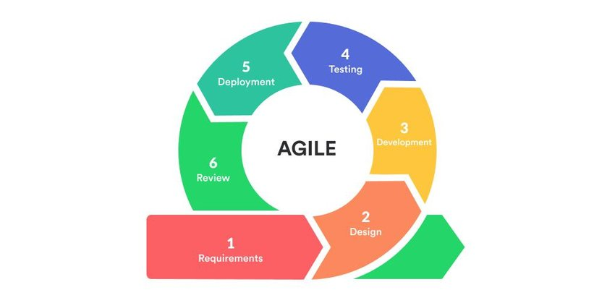

Figure 1. Agile Model (Software development life cycle)

The Agile methodology is a project management approach that involves breaking the project into phases and emphasizes continuous collaboration and improvement. It promotes collaboration among team members and encourages regular feedback and improvement throughout the project lifecycle. The researcher followed the phases of agile methodology. By breaking the project into phases, it allows for better planning and organization of tasks.

In the planning stage, the proponents collaborate with their adviser to collect information with the underlying problems of manual work at research office. Interviews were held with the research coordinator in order to understand the whole process of taking the tracing the alumni to the advantage of the researchers. Based on the collected information, the researchers will come up with a great plan on how to solve the problem of tracing the alumni in a better and efficient manner. This stage of planning is very important, making sure that all resources to be used are fully utilized, and the proposed solution is tailored to the needs of Central Philippine State University. All in all, the planning stage is a very crucial stage in the research process since it lays the groundwork for successful solution of the identified problem.

The second stage is the stage of design.prototyping is utilized to visually conceptualize the system. It aims to create a system that not only meets functional requirements but also delivers an intuitive and visually appealing user experience for the Alumni Tracer Management System of Central Philippine State University.

During the implementation stage, the Alumni Career Link system is coded based on user requirements and design specifications. The researchers build the system using Vue.js (a JavaScript framework), Tailwind CSS, and PrimeVue for the front-end, and Express.js (a Node.js framework) and Firebase for the back-end. This phase transitions the project from design to a functional, interactive system. Together, these technologies ensure a visually appealing and responsive front-end interface.

The testing stage is of major importance in making sure that the system is fit to meet the end-user's requirements. Some of the identified issues related to the system were dealt with, making sure the system functions at an optimum level and meets the requirements of the end-users through beta testing and surveys.

The fifth stage is system deployment. After thorough development and testing of functionality and usability, the Alumni Career Link system is launched online. Researchers introduce the system to end users, demonstrating its features. This stage ensures the system is accessible to end users, enabling them to benefit from its tools. During deployment, initial user feedback is gathered to identify any issues or improvements needed. User guides or orientation sessions are provided to help users become familiar with the platform. Technical support is also made available in case users encounter problems while using the system.

The last process involves reviewing specific functions and errors to ensure optimal system performance. Developers examine system functions to identify and resolve issues before release to end-users. This review includes UI (User Interface), security, and performance functions to ensure a seamless user experience. The error review covers deployment, compatibility, and logical errors to maintain system reliability. Thorough testing of these components helps prevent issues in production environments. Additionally, developers verify that the system meets all specified requirements and standards. This careful work makes sure the system is safe, stable, and works well for users.

|  |
| --- |
| **OUTPUT** |
| ALUMNI CAREER LINK: A SMART TRACKING SYSTEM BRIDGING GRADUATES AND EMPLOYMENT OPPROTUNITIES |

1. **Flow of the Study**





|  |
| --- |
| **INPUT** |
| Problem Statement:   1. What is the current process used by the Research Office of the university in terms of managing its alumni’s employability data and records? 2. What is the level of difficulty encountered by Central Philippines State University Planning Office San Carlos campus in terms of;    1. Maintain an updated alumni record.    2. Verifying employment information.    3. Analyzing employment trends accurately.    4. Addressing low response rates to tracer studies. 3. What are the technical requirements needed in the development of an Alumni Career Link: A Smart Tracking System Bridging Graduates and Employment Opportunities? 4. How efficient and usable is the development of Alumni Career Link: A Smart Tracking System Bridging Graduates and Employment Opportunities for Central Philippines State University? |

|  |
| --- |
| **PROCESS** |
| * SDLC Model   What is Agile development?   * Evaluation using PIECES Evaluation Framework |

Figure 2. Flow of the Study for the Alumni Career Link: A Smart Tracking System Bridging Graduates and Employment Opportunities.

The figure above shows the Input-Process-Output (IPO) data flow to ensure The Alumni Career Link produces the desired results. It outlines the systematic development and implementation of the web application for tracking alumni. First, the study gathers requirements from university administrators to understand their needs and challenges in managing alumni records specifically, tracking alumni employment status. Next, a detailed analysis of the current manual processes is conducted to identify areas where automation and digital tools can improve tracking and engagement.

1. **Functional and Non-Functional Requirements**

**c.1.Software Requirements**

Table 1 shows the software requirements that are needed in the development of the system. It indicated the required version of software utilized in the development process.

|  |  |
| --- | --- |
| **Software** | **Version** |
| Visual Studio Code | 1.98.2 |
| Firebase | 11.1.0 |
| Nuxt | 3.15.2 |
| Nuxt UI | 2.18.7 |
| Typescript | 5.6.3 |

Table 1. Software Requirements (Minimum) of the Alumni Career Link: A Smart Tracking System Bridging Graduates and Employment Opportunities

The Alumni Career Link: A Smart Tracking System bridging Graduates with Employment Opportunities, was developed using Visual Studio Code (VS Code) 1.98.2, provided a lightweight, flexible development environment with features like auto-completion, Git integration, and debugging, streamlining the coding process. Firebase 11.1.0 served as the secure, scalable database, lwith real-time updates for storing, manage alumni and job data. Nuxt 3.15.22, a Vue.js framework, enabled full-stack development, handling both front-end and back-end logic with server-side rendering for performance. Nuxt UI powered the system’s user interface, delivering a modern, responsive design, while TypeScript ensured type safety and enhanced code reliability. These tools were chosen for their compatibility, scalability, and ability to create a user-friendly, robust system. These technologies were carefully selected for their compatibility, ease of integration, and ability to produce a scalable and user-friendly system suitable for long-term deployment in university institutions.

**c.2. Hardware Requirements**

Table 2 shows the hardware requirements that needed for developing and utilizing the system.

|  |  |
| --- | --- |
| **Hardware** | **Specifications** |
| Computer Name | LAPTOP-DRT1RIT8 |
| OS (Operating System) | Windows 11 Home Single Language 24H2 (Build 26100.3476) |
| Processor | 12th Gen Intel® Core™ i5-1235U @ 1.30 GHz |
| Memory | 8.00 GB (7.70 GB usable) RAM |

Table 2. Hardware Requirements (Recommended) of the Alumni Career Link: A Smart Tracking System Bridging Graduates and Employment Opportunities

The hardware used for developing the Alumni Career Link was a LAPTOP-DRT1RIT8 running Windows 11 Home Single Language 24H2 (Build 26100.3476), offering a modern and secure environment for development. It was powered by a 12th Gen Intel® Core™ i5-1235U processor with a base clock speed of 1.30 GHz, providing efficient performance for coding, multitasking, and testing. With 8.00 GB (7.70 GB usable) RAM, the system supported smooth operation of development tools like Visual Studio Code, handling large datasets and multiple applications simultaneously. This hardware configuration ensured the necessary power, stability, and compatibility for creating and deploying the system effectively. The laptop provides ample storage for project files, databases, and development environments, enabling quick access and efficient data management. Additionally, the laptop’s portability allowed developers to work flexibly across different locations, ensuring consistent progress on the Alumni Career Link system. The laptop’s battery life allowed for extended work sessions without constant charging, contributing to productivity during off-site or not. The laptop also supported multiple external devices such as USB drives and external monitors, which helped expand the workspace and improve workflow efficiency. Regular system updates and security patches kept the development environment safe from vulnerabilities, ensuring data integrity throughout the project. Furthermore, the device’s lightweight design and compact form factor made it easy to carry between workspaces, supporting agile development practices. Overall, the hardware setup contributed significantly to maintaining productivity, collaboration, and smooth system deployment throughout the project.

**c.3. System/Application Flowchart**

This flowchart shows the process of data, where it should start and how it ends.

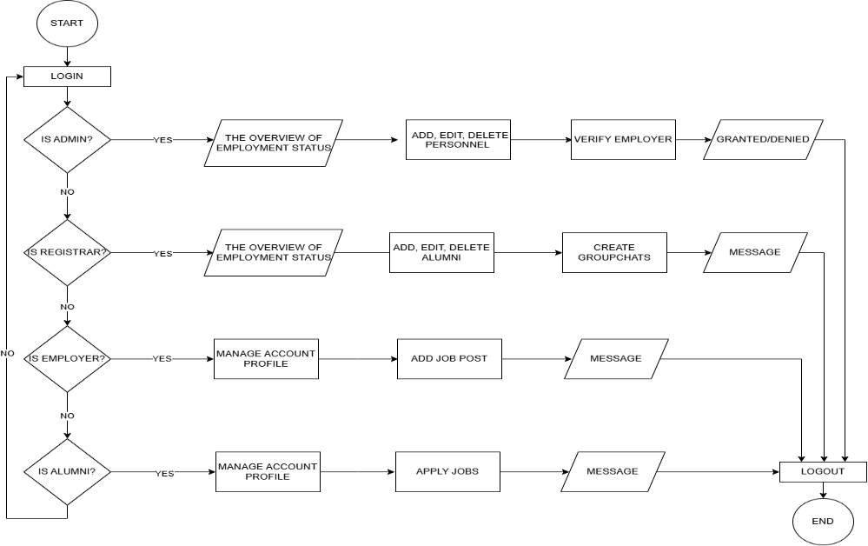

Figure 3. Proposed Flowchart Diagram for End Users.

The figure above presents a structured process of the Alumni Career Link through a clear flowchart. It begins with a secure login, granting access only to authorized users: administrators, registrars, alumni, and employers. Administrators can view employment trend graphs, manage school personnel by adding, editing, or deleting user records, and verify employer sign-ups to ensure only legitimate employers gain access. Registrars access trend graphs, manage alumni profiles by adding, editing, or deleting records, and create group chats to enhance engagement. Employers, once verified, post job openings and review applications, while alumni update their profiles and apply for jobs. Each user role has different features and functions, including adding, editing, or deleting profiles, posting or applying for jobs, and analyzing employment trends via data visualizations. This system ensures accurate records, strengthens alumni connections, and opens job opportunities by linking graduates to their professional futures.

**c.4. System Architecture**

System architecture refers to the design and structure of a computer system or software application.

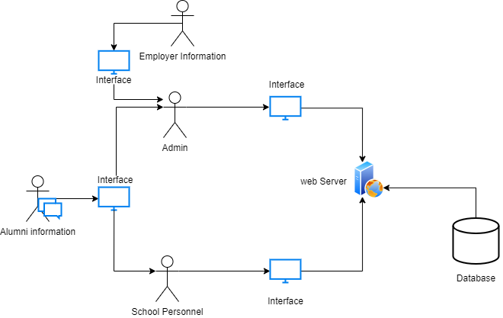

Figure 4. System Architecture for the Alumni Career Link: A Smart Tracking System Bridging Graduates and employment Opportunities

The system architecture above illustrates the design of a web application system that was crafted to connect universities, alumni, and employers. It centers on the User Interface, where administrators, registrars, alumni, and employers interact with the system. The User Interface integrates smoothly with a secure database to store and retrieve alumni profiles, employment data, and job postings, ensuring data accuracy and accessibility. Additionally, the architecture supports real-time data of alumni and group chats, fostering alumni engagement even across diverse locations, and strengthens university and graduates’ connections.

**c.5. Context Diagram**

Context diagram illustrates how the data processed by the system in terms of input and output.

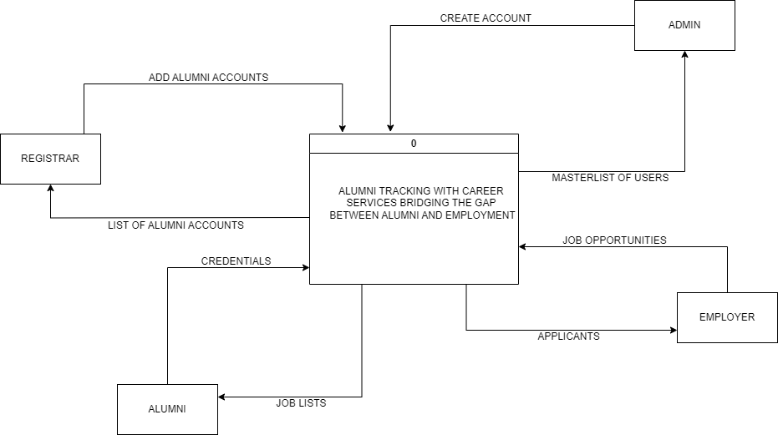

Figure 5. Context Diagram for the Alumni Career Link System

The Context Level Data Flow Diagram (DFD) for The Alumni Career Link: A Smart Tracking System Bridging Graduates and Employment Opportunities illustrates the interactions between external entities and the system. Each end-user has a different role to interact and engage with the system, fulfilling their distinct purposes. The system acts as a central hub, managing these data flows to connect universities, alumni, and employers efficiently.

**c.6. Data Flow Diagram**

A data flow diagram is a graphical representation of the floe of data through an information system.

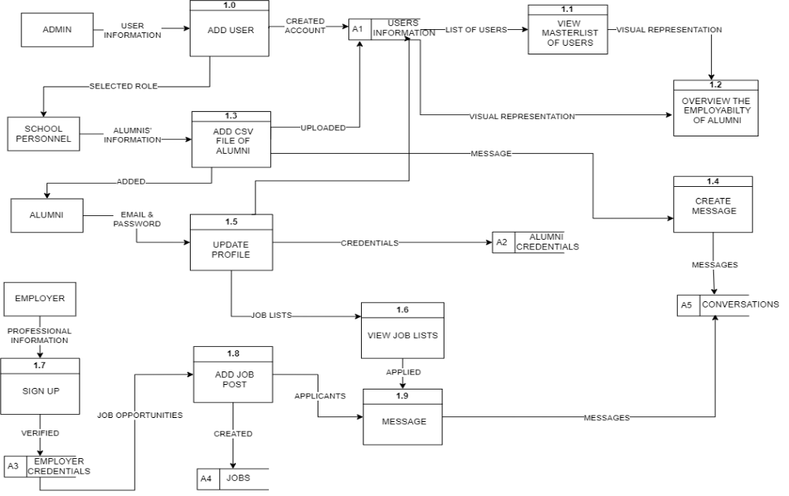

Figure 6. Proposed Data Flow Diagram for End Users

The Data Flow Diagram (DFD) above provides a detailed visualization of system core functionalities and data interactions. It demonstrates how Admin, School Personnel, Alumni, and Employer entities interact with the system to manage alumni and job data, encompassing user accounts, employment trends, and job opportunities. The system is structured into key processes: adding user accounts, managing alumni profiles, posting and applying for jobs, and facilitating communication through messages. Each process handles specific inputs such as user information, alumni CVs, job posts, and messages—and subsequently updates dedicated data stores for user records, alumni credentials, employer credentials, job listing, and conversations. The system also generates a visual representation of employment trends, ensuring transparency and clarity in tracking alumni outcomes. This DFD highlights the system’s logical flow and centralized approach, promoting efficiency, accuracy, and reliable data management in connecting universities, alumni, and employers. The clear separation of processes and data stores also supports data security and privacy by controlling access based on user roles. Overall, this diagram serves as a roadmap for developers and for the end users to understand system operations and ensure alignment with user needs and institutional goals.

**c.7. Entity Relationship Diagram**

This diagram shows the relationship of the entities in the database.

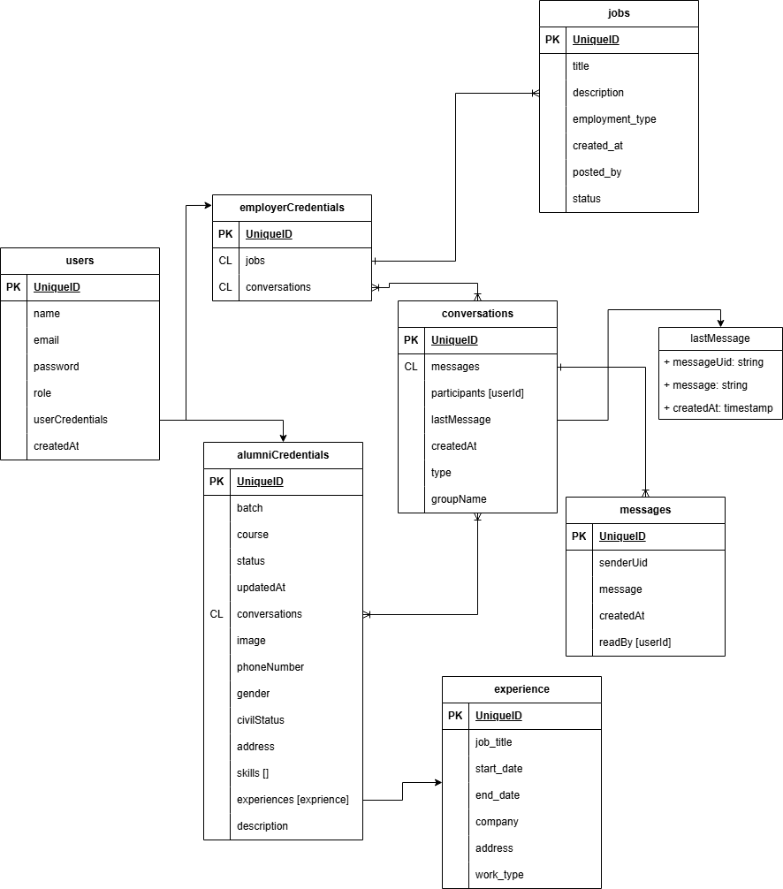

Figure 7. ERD of the Alumni Career Link System

The Entity-Relationship Diagram for the Alumni Career Link: A Smart Tracking System Bridging Graduates and Employment Opportunities shows how the system’s database is set up to handle alumni, jobs, and communication. The “users” table stores everyone’s basic info like name, email, role, and for alumni details like batch and course. Alumni data links to an “experience” table to track their work history, such as job titles and dates. Employers’ info connects to a “jobs” table with job postings, including titles and descriptions. The “conversations” and “messages” tables let users chat, storing who’s talking and what they’re saying. This setup helps the system keep everything organized, making it easier to track alumni, and connect them with jobs.

**c.8. Use case Diagram**

A use case diagram is a visual representation of how users interact with a system to achieve specific goals or functions.

**c.8.1. Admin Use case Diagram**

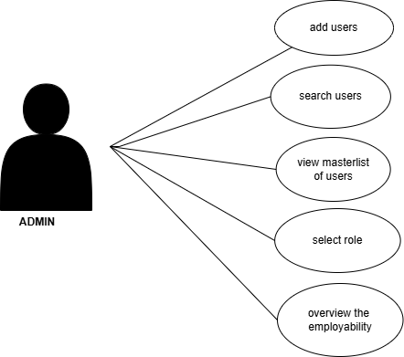

Figure 8. Use case Diagram for the Admin

The Use Case Diagram for The Alumni Career Link: A Smart Tracking System Bridging Graduates and Employment Opportunities highlights how users interact with the system. Admins manage users by adding accounts, viewing the master list, searching users, and selecting roles. They also oversee employability trends of the alumni. In addition, admins can view the generated reports of employment data, manage the users by assigning roles to determine who among the school personnel can access the system, and ensure that all user activities align with the system’s goals of tracking and connecting graduates to job opportunities.

**c.8.2. School Personnel Use case Diagram**

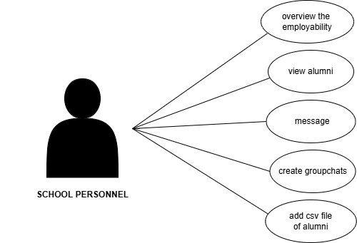

Figure 9. Use case Diagram for the School Personnel

The School Personnel users can view employability data of alumni, check alumni profiles, create group chats, and add CSV files of alumni. They can also update alumni records, send announcements to the group chats and monitor employment trends over time. These features help make communication between the school and its graduates easier and improve the way alumni information is handled and used for career-related programs. They also allow the school to keep track of employment trends and identify areas where graduates have a low employment rate.

**c.8.3. Employer Use case Diagram**

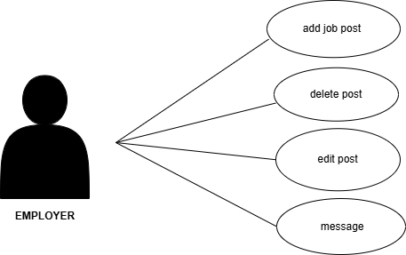

Figure 10. Use case Diagram for the Employer

Employers add, edit, or delete job posts and also use messaging to communicate with applicants. This diagram shows how the system supports distinct roles to efficiently connect universities, alumni, and employers, enhancing job opportunities and engagement. Employers can view applicant profiles, review their educational background and achievements, and communicate directly with potential candidates. Employers can choose to hire those who meet their expectations based on the information provided. This direct interaction helps ensure job offers reach qualified graduates and creates a more personal and flexible hiring process. By using the system, employers help strengthen the connection between schools and the workforce, increasing job opportunities for graduates.

**c.8.4. Alumni Use case Diagram**

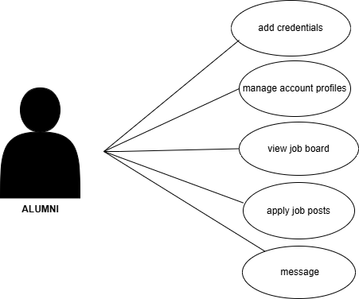

Figure 11. Use case Diagram for the Alumni

Alumni manage their profiles, add credentials, view job boards, apply for job posts, and interact with employers. They can update their employment status, educational background, and other relevant information to keep their records current. The messaging feature allows them to directly communicate with employers for inquiries or interview schedules. By keeping their profiles active and complete, they increase their chances of getting hired. The system also helps alumni stay connected with their university by receiving messages from alumni group chats, and participating in school-related activities or events. It provides a platform where alumni can engage with fellow graduates, share professional experiences, and offer guidance to current students.

**d. Respondents**

Table 3. Distribution of Respondents

|  |  |  |
| --- | --- | --- |
| **Respondents** | **Population** | **Percentage** |
| CPSU Students  School Personnel | 150  2 | 98.68%  1.32% |
| **Total** | 152 | 100% |

The respondents primarily consist of fourth-year students from Central Philippines State University, San Carlos Campus, along with selected school personnel such as department heads and the admin. These individuals participated in evaluating the system designed to make it easier to search alumni information and monitor employment status. The involvement of graduating students ensures that the feedback reflects the actual needs of future alumni users. Meanwhile, input from administrative staff helps assess the system’s usefulness in supporting school records and graduate tracking.

**e. Environment**

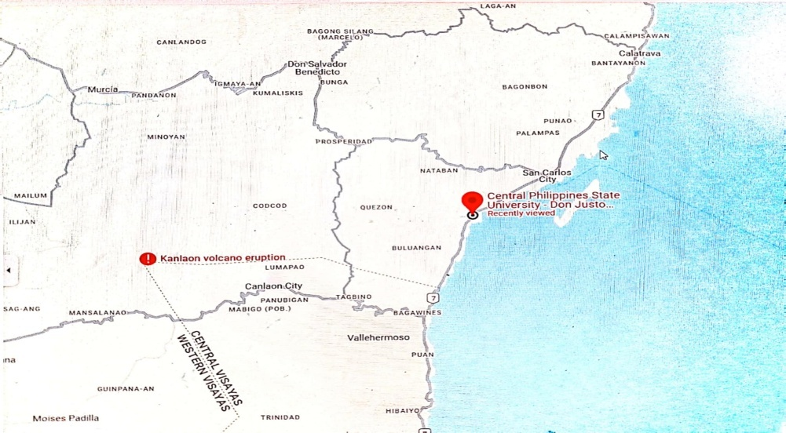

Figure 12. The Central Philippines State University San Carlos Campus

The proponents conducted the study at the university's location, specifically at Don Justo V. Valmayor Campus in San Carlos City, Negros Occidental. The study focused on the university where the system will be implemented and utilized.

**f. Data Gathering Procedures**

The primary data were obtained directly from sources through an evaluation form based on the PIECES Software Evaluation Framework, as assessed by end-users and IT experts. To conduct the study, the proponents utilized a survey method by distributing questionnaires to collect respondents' ratings of the system.

**g. Research Instrument and Statistical Treatment of Data**

How effective and efficient is the Alumni Career Link: A Smart Tracking System bridging Graduates and Employment Opportunities using PIECES Software Evaluation Framework Questionnaire. This standardized questionnaire was used in evaluating the end-users satisfactory rating on the effectiveness, efficiency, and usability of this web application. The areas consist of performance, information, economy, control, efficiency and services were evaluated to assess the functionality of the develop system. For each question in each area, the respondents answered based on a structured 5-point Likert Scale with the verbal description: 5 (Very Satisfied), 4 (Satisfied), 3 (Quite Satisfied), 2 (Dissatisfied), and 1 (Very Dissatisfied). Each question in every area was scored, and the results were analyzed using frequency count, total score and weighted mean to determine how many respondents gave a certain rating and what the overall average rating was per category. This method helped identify how often a specific rating was given (frequency), how well the system performed overall (total score), and what the general satisfaction level was (weighted mean). The collected data provides valuable insights into the strengths and weaknesses of the system from the users’ perspective. It also guides developers in pinpointing which areas require improvement and which features are well-received. By using this structured evaluation approach, the study ensures that the system meets the practical needs of its users.

**Table 4.** Likert Scale

|  |  |  |
| --- | --- | --- |
| Rating | Weighted Mean | Verbal description |
| 5 | 4.21-5.00 | Very Satisfied |
| 4 | 3.41-4.20 | Satisfied |
| 3 | 2.61-3.40 | Quite Satisfied |
| 2  1 | 1.81-2.60  1.00-1.80 | Dissatisfied  Very Dissatisfied |

The responses for each indicator in the system’s evaluation areas which consist of performance, information, economy, control, efficiency and services were collected using a 5-point Likert Scale: 5 (Very Satisfied), 4 (Satisfied), 3 (Quite Satisfied), 2 (Dissatisfied), and 1 (Very Dissatisfied). The frequency of responses was computed to assess the level of agreement among respondents for each item, reflecting their satisfaction with the system’s features.

The Effectiveness, Efficiency and Usability of the Alumni Career Link: a smart Tracking system bridging Graduates and Employment Opportunities in Central Philippines State University San Carlos Campus assessed and evaluated by end-users and IT (Information Technology) Experts

**CHAPTER IV**

**RESULTS, CONCLUSIONS, & RECOMMENDATIONS**

**a. Results and Discussion**

The evaluation results provide an insightful analysis of the system's performance, focusing on key areas such as effectiveness, efficiency, and usability of the Alumni Career Link: a smart Tracking system bridging Graduates and Employment Opportunities These aspects were assessed and evaluated by end-users and IT (Information Technology) Experts. The findings reveal how well the system met its intended goals, how effectively it supports users in completing tasks, and the overall satisfaction of users with their interactions. By evaluating the system from multiple perspectives, the results offer valuable information on its strengths and areas for improvement, ensuring that the system evolves to better meet the needs of its users. The following sections discuss the detailed evaluation results and their implications for future system enhancements.

**Table 5*.*** Responses of the Students on the Development of Alumni Career Link: A Smart Tracking System Bridging Graduates and Employment Opportunities in terms of Performance throughout and response time.

|  |  |  |
| --- | --- | --- |
| **Indicators** | **Weighted Mean** | **Interpretation** |
| 1. The web system quickly processes my employment information updates. | 4.50 | Very Satisfied |
| 1. The system allows me to apply for jobs efficiently, even outside my field. | 4.50 | Very Satisfied |
| 1. The system’s group chat feature works smoothly without delays. | 4.50 | Very Satisfied |
| **Overall Weighted Mean** | **4.50** | **Very Satisfied** |

The table presents the responses of students from the CPSU San Carlos Campus regarding the Alumni Career Link: A Smart Tracking System Bridging Graduates and Employment Opportunities in terms of performance, throughput, and response time, with an overall weighted mean of 4.50, indicating they were very satisfied. The students rated the system’s ability to quickly process employment information updates at 4.50, showing that it handles data updates efficiently and without delays. The group chat feature, which works smoothly without delays, was also rated at 4.50, indicating reliable and fast communication. In simple words, the students strongly agreed that the system is fast at updating information, applying for jobs, and supporting smooth group chats, making it a highly effective and responsive tool for CPSU graduates. In relation to Rosauro’s study (2017), which revealed high user satisfaction due to the system’s quality, information accuracy, and service reliability, particularly in tracking employment status and facilitating communication.

**Table 6*.*** Responses of the Students on the Development of Alumni Career Link: A Smart Tracking System Bridging Graduates and Employment Opportunities in terms of Information, Input, Output, and Data Storing*.*

|  |  |  |
| --- | --- | --- |
| **Indicators** | **Weighted Mean** | **Interpretation** |
| 1. The system accurately reflects my employment updates. | 4.47 | Very Satisfied |
| 1. The group chat feature delivers useful updates from CPSU staff. | 4.57 | Very Satisfied |
| 1. The system ensures my job applications are sent correctly to employers. | 4.55 | Very Satisfied |
| **Overall Weighted Mean** | **4.53** | **Very Satisfied** |

The table shows the responses of students from the CPSU San Carlos Campus regarding the Alumni Career Link: A Smart Tracking System Bridging Graduates and Employment Opportunities in terms of Input, Output and Data Storing with an overall weighted mean of 4.53, indicating they were very satisfied. The students rated the system’s ability to accurately reflect their employment updates at 4.47, suggesting it reliably tracks and displays their career information. The group chat feature, which provides useful updates from CPSU staff, received the highest score of 4.57, showing that students value the timely and relevant communication it offers. Additionally, the system’s ability to ensure job applications are sent correctly to employers was rated at 4.55, indicating accuracy and reliability for job submissions. In simple words, the students strongly agreed that the system accurately updates their employment details, provides helpful staff updates through chats, and sends job applications correctly, making it a very effective tool for CPSU graduates in managing their careers. Rosauro’s (2017) study confirms the CPSU Alumni Career Link’s effectiveness in facilitating career management and collaboration among graduates, employers, and staff, highlighting its potential as a model for institutions aiming to connect alumni with employment opportunities.

**Table 7*.*** Responses of the Students on the Development of Alumni Career Link: A Smart Tracking System Bridging Graduates and Employment Opportunities in terms of Control & Security.

|  |  |  |
| --- | --- | --- |
| **Indicators** | **Weighted Mean** | **Interpretation** |
| 1. My personal and employment data are securely protected. | 4.57 | Very Satisfied |
| 1. I can control what information I share in chats or with employers. | 4.54 | Very Satisfied |
| 1. The system prevents unauthorized access to my profile. | 4.52 | Very Satisfied |
| **Overall Weighted Mean** | **4.54** | **Very Satisfied** |

The table presents the responses of students from the CPSU San Carlos Campus regarding the Alumni Career Link: A Smart Tracking System Bridging Graduates and Employment Opportunities in terms of control and security, with an overall weighted mean of 4.54, indicating they were very satisfied. The students rated the security of their personal and employment data highly, with a score of 4.57, showing strong confidence that the system keeps their information safe. They also gave a score of 4.54 for the ability to control what information they share in chats or with employers, suggesting the system provides good privacy options and user control. Additionally, the system’s ability to prevent unauthorized access to profiles was rated at 4.52. In simple terms, the students strongly agreed that the system is secure, and keeps their profiles safe from unauthorized access, making it a reliable and trustworthy tool for CPSU graduates. Similarly, Luciano’s (2020) study reported high user satisfaction due to secure data management, user verification, and controlled access to alumni profiles, aligning with the proponent’s system. This consistency underscores the importance of security and user control in alumni tracking systems, validating the system’s reliability and its potential as a model for secure alumni engagement platforms. The positive feedback from students reflects the system's role in building trust and encouraging active participation among alumni.

**Table 8.**Responses of the Students on the Development of Alumni Career Link: A Smart Tracking System Bridging Graduates and Employment Opportunities in terms of Efficiency.

|  |  |  |
| --- | --- | --- |
| **Indicators** | **Weighted Mean** | **Interpretation** |
| 1. The system makes updating my employment info is quick and simple. | 4.49 | Very Satisfied |
| 1. The system streamlines applying to jobs, even outside my field. | 4.55 | Very Satisfied |
| 1. The system is compatible with various devices, including tablets and PCs. | 4.57 | Very Satisfied |
| **Overall Weighted Mean** | **4.53** | **Very Satisfied** |

The table shows how students from the CPSU San Carlos Campus rated the efficiency of the Alumni Career Link: A Smart Tracking System Bridging Graduates and Employment Opportunities with an overall weighted mean of 4.53, meaning they were very satisfied. The students gave a score of 4.49 for how quick and simple it is to update their employment information, indicating the system is easy to use and efficient for keeping their profiles current. The highest score, 4.57, was for the system’s compatibility with different devices like tablets and PCs, meaning it works well and is accessible on various platforms. In simple words, the students strongly agreed that the system is fast, easy for job applications, and works great on multiple devices, making it a very helpful tool for CPSU graduates in their career journeys. Based on Epoc’s (2020) study, this consistency highlights the importance of user-friendly interfaces and platform compatibility in alumni tracking systems, validating the system’s role as an effective tool for career management and a potential model for other institutions aiming to enhance alumni engagement through efficient technology.

**Table 9*.*** Responses of the Students on the Development of Alumni Career Link: A Smart Tracking System Bridging Graduates and Employment Opportunities in terms of Service*.*

|  |  |  |
| --- | --- | --- |
| **Indicators** | **Weighted Mean** | **Interpretation** |
| 1. The system is easy to use and navigate | 4.56 | Very Satisfied |
| 1. It is always accessible without any issues. | 4.52 | Very Satisfied |
| 1. The system improves my overall experience as a CPSU alumnus | 4.60 | Very Satisfied |
| **Overall Weighted Mean** | **4.55** | **Very Satisfied** |

The table above presents the overall service evaluation of the Alumni Career Link: A Smart Tracking System Bridging Graduates and Employment Opportunities, which received a high rating from respondents, with a weighted mean of 4.55. The respondents, students from CPSU San Carlos Campus, rated the system highly for its ease of use and navigation, with a score of 4.56. This indicates that the system is simple, clear, and easy to use. In terms of accessibility, the system received a rating of 4.52, suggesting that users can access it at any time without difficulty. The highest score, 4.60, was given to the system’s contribution to enhancing the alumni experience, implying that it effectively supports graduates in finding jobs and connecting with career opportunities. Overall, the students strongly agreed that the system is user-friendly, reliable, and highly beneficial for their career development, making it a valuable tool for CPSU graduates. Furthermore, the positive feedback reflects the system’s ability to meet user expectations and support their transition from student life to employment. The consistently high ratings across all service aspects indicate that the system delivers a smooth and satisfying user experience, fostering ongoing use and engagement among alumni. These findings align with Calibo-Senit’s (2019) study, which emphasized the system’s design and reliable accessibility. This consistency highlights the system’s effectiveness in delivering high-quality services, promoting alumni engagement, and serving as a valuable tool for educational institutions seeking to enhance alumni employment through accessible and user-friendly digital platforms.

In this section, the frequency method was used to analyze the responses of school personnel from CPSU San Carlos Campus, gathered through the PIECES Software Evaluation Framework Questionnaire. This method helps show how often each rating (from 1 to 5) was selected by the respondents in each evaluation area—Performance, Information, Economy, Control, Efficiency, and Services. By counting how many times each score was chosen, it becomes easier to understand the overall satisfaction level and how the system performed based on actual user feedback. This approach provides a clear picture of which parts of the system met expectations and which areas may need improvement. It also helps highlight trends in user perception, making it easier to prioritize future updates or enhancements.

**Table 10.**Responses of the School Personnel on the Development of Alumni Career Link: A Smart Tracking System Bridging Graduates and Employment Opportunities. in terms of Performance throughout and Response Time*.*

|  |  |  |  |  |  |
| --- | --- | --- | --- | --- | --- |
|  | **Frequency** | | | | |
| **Indicators** | **Very Satisfied** | **Satisfied** | **Quite Satisfied** | **Dissatisfied** | **Very Dissatisfied** |
| 1. The system quickly processes alumni updates and employment verification. | 1 | 3 |  |  |  |

|  |  |  |  |  |  |
| --- | --- | --- | --- | --- | --- |
| 1. The chat feature performs reliably without delays. | 2 | 2 |  |  |  |
| 1. The system verifies employer legitimacy promptly. | 1 | 1 | 2 |  |  |
|  |  |  |  |  |  |

The table presents feedback from school personnel at CPSU San Carlos Campus, showing a generally positive view of the Alumni Career Link system. Most rated the system as either Satisfactory or Very Satisfactory, indicating its effectiveness in processing alumni updates and employment verification. The chat feature was also viewed positively, with respondents finding it reliable and responsive. According to the study by Sucipto et al. (2020), system speed and responsiveness are essential in alumni tracking platforms. Their findings showed that features like automated messaging can greatly enhance user experience by improving response times and communication. Overall, the feedback suggests that the CPSU system is performing efficiently and meeting user expectations. This responsiveness not only supports smoother operations but also builds user trust in the system.

**Table 11**. Responses of the School Personnel on the Development of Alumni Career Link: A Smart Tracking System Bridging Graduates and Employment Opportunities. in terms of Information, Input, Output, and Data Storing.

|  |  |  |  |  |  |
| --- | --- | --- | --- | --- | --- |
|  | **Frequency** | | | | |
| **Indicators** | **Very Satisfied** | **Satisfied** | **Quite Satisfied** | **Dissatisfied** | **Very Dissatisfied** |
| 1. The system accurately records alumni employment data I update. | 3 | 1 |  |  |  |
| 1. The graphical employment trends provide clear, actionable insights. | 1 | 3 |  |  |  |
| 1. The chat feature delivers useful communication with alumni. | 2 | 2 |  |  |  |
|  |  |  |  |  |  |

The responses from school personnel at CPSU San Carlos Campus show a favorable view of the Alumni Career Link system’s functionality. The majority rated the system as Very Satisfactory or Satisfactory, especially in accurately recording alumni employment data, reflecting strong confidence in this feature. The graphical employment trends were positively received for providing clear and actionable insights that support decision-making. Additionally, the chat feature was recognized as a helpful tool for maintaining communication with alumni. Overall, the responses highlight the system’s effectiveness in supporting alumni tracking and engagement. Similarly, Lopez et al. (2019) emphasized the importance of reliable data input and clear output for effective alumni tracking and institutional planning.

**Table 12.** Responses of the School Personnel on the Development of Alumni Career Link: A Smart Tracking System Bridging Graduates and Employment Opportunities in terms of Control & Security.

|  |  |  |  |  |  |
| --- | --- | --- | --- | --- | --- |
|  | **Frequency** | | | | |
| **Indicators** | **Very Satisfied** | **Satisfied** | **Quite Satisfied** | **Dissatisfied** | **Very Dissatisfied** |
| 1. The system securely stores alumni data and employer information. | 2 | 2 |  |  |  |
| 1. The system restricts graphical trend data to authorized staff only | 2 | 2 |  |  |  |
| 1. The system prevents unauthorized access to chats or records. | 2 | 2 |  |  |  |
|  |  |  |  |  |  |

The responses from school personnel at CPSU San Carlos Campus show strong satisfaction with the security features of the Alumni Career Link system. The consistently rated data storage, access control to graphical trend data, and protection against unauthorized access as either Very Satisfactory or Satisfactory. This feedback indicates trust in the system’s ability to securely handle sensitive alumni and employer information while limiting access to authorized personnel. These findings align with Kumar and Singh’s (2020) study, which emphasizes the importance of role-based access and data protection to maintain confidentiality and user trust. This comparison highlights the system’s effectiveness in securing the data, ensuring privacy, and complying with data protection standards.

**Table 13.**Responses of the School Personnel on the Development of Alumni Career Link: A Smart Tracking System Bridging Graduates and Employment Opportunities Efficiency.

|  |  |  |  |  |  |
| --- | --- | --- | --- | --- | --- |
|  | **Frequency** | | | | |
| **Indicators** | **Very Satisfied** | **Satisfied** | **Quite Satisfied** | **Dissatisfied** | **Very Dissatisfied** |
| 1. The system simplifies updating alumni employment records. | 4 |  |  |  |  |
| 1. The system streamlines generating graphical employment trend reports. | 2 | 2 |  |  |  |
| 1. The group chat feature makes communicating with alumni efficient. | 2 | 2 |  |  |  |
|  |  |  |  |  |  |

The responses from school personnel at CPSU San Carlos Campus expressed a highly positive view of the system’s efficiency. All respondents rated the feature for updating alumni employment records as Very Satisfactory, indicating that the process is simple and user-friendly. The ability to generate graphical employment trend reports was also well-received, with ratings evenly split between Very Satisfactory and Satisfactory, showing that users find the reporting feature helpful and accessible. Similarly, the group chat feature was acknowledged for enhancing communication efficiency with alumni, receiving a balanced mix of Very Satisfactory and Satisfactory responses. These results suggest that the system supports the school’s goals in maintaining alumni data and helps staff perform their duties more efficiently. As supported by Cruz et al. (2018), an efficient system helps achieve institutional goals and provides better service. This allows the institution to make more informed decisions and track graduate outcomes with greater ease.

**Table 14.**Responses of the School Personnel on the Development of Alumni Career Link: A Smart Tracking System Bridging Graduates and Employment Opportunities in terms of Service*.*

|  |  |  |  |  |  |
| --- | --- | --- | --- | --- | --- |
|  | **Frequency** | | | | |
| **Indicators** | **Very Satisfied** | **Satisfied** | **Quite Satisfied** | **Dissatisfied** | **Very Dissatisfied** |
| 1. The system reliably supports managing alumni data and employer verification. | 2 | 2 |  |  |  |
| 1. The group chat feature enhances communication with alumni effectively. | 1 | 3 |  |  |  |
| 1. The system meets expectations for tracking trends and verifying employers. | 1 | 3 |  |  |  |
|  |  |  |  |  |  |

The feedback from school personnel at CPSU San Carlos Campus indicates consistent satisfaction with the system’s reliability and functionality. Managing alumni data and verifying employers received a mix of Very Satisfactory and Satisfactory responses, suggesting that the system performs these tasks dependably. The group chat feature was also viewed positively, with respondents agreeing that it enhances communication with alumni. Tracking trends and verifying employers also met user expectations, as reflected in the similar pattern of ratings. The system helps reduce manual work, allowing staff to focus more on monitoring graduate outcomes and maintaining strong alumni relations. These results show that the system is a valuable tool for daily administrative operations related to graduate tracking and employment. In relation, a study by Sudjoko et al. (2022) emphasized the role of service quality in alumni satisfaction, highlighting that efficient service delivery in schools significantly boosts alumni engagement and trust. This supports the importance of systems like the Alumni Career Link in offering dependable services that help institutions achieve their goals.

**b. Implementation Plan**

Implementing the alumni tracking system with career services will simplify the process of tracking alumni information and their employment status, compared to manually entering data and individually reaching out to alumni. The system can store all records of alumni, tracks employment status, provide career services and fosters connections. The researchers plan to conduct an orientation session to minimize system errors and guide end users on how to use the alumni career link: a smart tracking system bridging graduates and employment opportunities properly. These sessions will include hands-on demonstrations and user-friendly guides to ensure that both faculty and graduating students, who are about to leave the school and will soon be considered alumni, are comfortable with the system. Alumni will be able to manage their profiles, apply for jobs, while employers can post job openings and track alumni applications. This makes it easier to track the whereabouts of alumni, ensuring that the school personnel can access this information whenever needed.

The proponent is currently working on a system that will benefit both the school and the alumni. This system will make it easier for faculty members to monitor alumni employment status without the need to contact them individually. It will generate reports about alumni career progress and manage their personal information. The system will also include a job posting feature, where alumni can find and apply for job opportunities through the platform. Once the system is finished, it will be tested to ensure it works properly and is secure. After testing, the system will be introduced to users in stages, starting with a small group to gather feedback. This feedback will be used to improve the system by adding features and making it better suited to user needs. Once everything is ready, the system will be fully launched, and support will be provided to help users get started and make the most of the platform. The system will also offer messaging tools to allow easier communication between alumni, school staff, and employers. Through this, alumni can stay updated on school events, job fairs, and announcements. Data collected from alumni will help the school analyze employment trends, improve its academic programs, and build stronger ties with graduates.

To ensure the system continues to function effectively after implementation, maintenance will be carried out. This includes monitoring the system to identify and fix any issues, and ensuring the system stays secure against new threats. User feedback will be collected to identify areas for improvement. Training and support will be provided to help users adapt to updates. Additionally, an admin will be assigned to manage the system, ensuring it remains reliable and provides long-term benefits to both end users. The updates will be applied to improve performance, fix bugs, and introduce new features based on evolving user needs

**Gantt Chart**

This chart shows the development of the activities done.

|  |  |  |  |  |  |  |  |  |  |
| --- | --- | --- | --- | --- | --- | --- | --- | --- | --- |
|  | Dec | Jan | Feb | March | Apr | May | Jan | Feb | March |
| ACTIVITIES | 1-4 | 1-4 | 1-4 | 1-4 | 1-4 | 1-4 | 1-4 | 1-4 | 1-4 |
|  |  |  |  |  |  |  |  |  |  |
| CHAPTER 1 |  |  |  |  |  |  |  |  |  |
| INTRODUCTION |  |  |  |  |  |  |  |  |  |
| STATEMENT OF THE PROBLEM |  |  |  |  |  |  |  |  |  |
| OBJECTIVES |  |  |  |  |  |  |  |  |  |
| SIGNIFICANCE OF THE STUDY |  |  |  |  |  |  |  |  |  |
| SCOPE AND LIMITATIONS |  |  |  |  |  |  |  |  |  |
| DEFINITION OF TERMS |  |  |  |  |  |  |  |  |  |
| CHAPTER 2 |  |  |  |  |  |  |  |  |  |
| REVIEW OF RELATED LITERATURE AND SYSTEMS |  |  |  |  |  |  |  |  |  |
| CHAPTER 3 |  |  |  |  |  |  |  |  |  |
| METHODOLOGY |  |  |  |  |  |  |  |  |  |
| DESIGN METHOD |  |  |  |  |  |  |  |  |  |
| INPUT-PROCESS-OUTPUT |  |  |  |  |  |  |  |  |  |
| NON AND FUNCTIONAL REQUIREMENTS |  |  |  |  |  |  |  |  |  |
| PROPOSED FLOWCHART |  |  |  |  |  |  |  |  |  |
| SYSTEM ARCHITECTURE |  |  |  |  |  |  |  |  |  |
| CONTEXT DIAGRAM |  |  |  |  |  |  |  |  |  |
| DATA FLOW DIAGRAM |  |  |  |  |  |  |  |  |  |
| ENTITY RELATIONSHIP DIAGRAM |  |  |  |  |  |  |  |  |  |
| USE CASE DIAGRAM |  |  |  |  |  |  |  |  |  |
| RESPONDENTS |  |  |  |  |  |  |  |  |  |
| ENVIRONMENT |  |  |  |  |  |  |  |  |  |
| DATA GATHERING PROCEDURES |  |  |  |  |  |  |  |  |  |
| RESEARCH INSTRUMENT AND STATISTICAL TREATMENT OF DATA |  |  |  |  |  |  |  |  |  |
| CHAPTER 4 |  |  |  |  |  |  |  |  |  |
| RESEARCH AND DISCUSSION |  |  |  |  |  |  |  |  |  |
| IMPLEMENTATION PLAN |  |  |  |  |  |  |  |  |  |
| GANTT CHART |  |  |  |  |  |  |  |  |  |
| BUDGET RECOMMENDATION |  |  |  |  |  |  |  |  |  |
| TESTING |  |  |  |  |  |  |  |  |  |
| EVALUATION |  |  |  |  |  |  |  |  |  |
| FINDINGS |  |  |  |  |  |  |  |  |  |
| CONCLUSIONS |  |  |  |  |  |  |  |  |  |
| RECOMMENDATIONS |  |  |  |  |  |  |  |  |  |
| BIBLIOGRAPHY |  |  |  |  |  |  |  |  |  |
| APPENDICES |  |  |  |  |  |  |  |  |  |
| Biographical Sketch |  |  |  |  |  |  |  |  |  |

Figure 13. Gantt Chart

**c. Budget Recommendation**

The table shows the budget recommendation for the implementation of the system.

|  |  |  |  |  |
| --- | --- | --- | --- | --- |
| PARTICULARS | SPECIFICATION | QUANTITY | COST/UNIT  (Php) | TOTAL  (Php) |
| Hardware |  |  |  |  |
|  | Laptop  Mobile Phone | 2  1 | 60, 000.00  10,000.00 | 60,000.00  10,000.00 |
|  |  |  |  |  |
| Software | Domain Name  Firebase  Vercel | 500  1,000  1,000 | 500.00  1,000.00  1,000.00 | 500.00  1,000.00  1,000.00 |
| GRAND TOTAL |  |  |  | 90, 500.00 |

Table 14. Recommended Budget for the Implementation of the System

The budget for the Alumni Career Link system, totaling Php 90,500.00, covers both hardware and software needs to support the development and implementation of the platform. The hardware includes two laptops priced at Php 30,000.00 each, totaling Php 60,000.00 for staff and admin use, and one mobile phone for alumni costing Php 10,000.00, providing the necessary tools for testing and accessing the system across multiple devices. On the software side, costs include domain name registration for Php 500.00, and monthly subscriptions to Firebase and Vercel at Php 1,000.00 each, which are essential for hosting, real-time database management, and deployment of the web application. This budget is feasible for institutions like Central Philippines State University – San Carlos Campus, as it ensures reliable hardware for development and testing, while securing software services that enable smooth system operation. The laptop supports development tasks and user interface testing, while mobile phones allow for checking system responsiveness on different devices. The domain name and hosting services provide a professional online presence and stable environment for users to access the system anytime.

Overall, the recommended budget provides a balanced and practical approach that covers the critical components needed to successfully implement and maintain the Alumni Career Link system, helping the university prepare financially for the project’s deployment and long-term use.

**d. Findings**

The system aimed to verify that the Alumni Career Link: A Smart Tracking System Bridging Graduates and Employment Opportunities meets its goals of tracking alumni employment, managing records, and facilitating decision-making through data visualization for CPSU San Carlos Campus administrators. It evaluates core functionalities such as data entry, employment tracking, graphical visualization, control and security. Testing was conducted using a combination of manual assessments by administrators and end-user feedback via survey questionnaires, focusing on real-world usability and system performance to determine.

Prior to the system’s implementation, administrators relied on manual record-keeping to keeps information and track alumni employment. This approach resulted in data redundancy, and inconsistent records. Tracking alumni whereabouts and employment status was time-consuming, and manual data compilation for reports occasionally led to errors. The Alumni Career Link successfully addressed these issues. It accurately stored alumni data, provided real-time employment tracking, and generated graphical visualizations for trend analysis. Testing confirmed that features like job opportunity and user dashboards functioned as intended. Performance, Information, Control, Efficiency and Service were rated highly, with administrators noting significant time savings compared to manual methods. Security tests verified that personal data was secured and protected against unauthorized access and no high-severity issues were identified, indicating the system’s overall stability and reliability.

To assess the system’s effectiveness, administrators and alumni tested its features and provided ratings via a survey questionnaire. The system was evaluated based on effectiveness, efficiency and usability of the system. Results showed a grand mean rating of all evaluations from both students and school personnel is 4.51, which falls under the “Very Satisfied**”** assessment. Respondents satisfied the system’s ability to streamline employment tracking, enhance data accuracy, and provide actionable insights through visualizations, significantly improving upon the previous manual processes.

**e. Conclusion**

The findings confirm that the Alumni Career Link performs reliably, meeting its goal of bridging graduates with employment opportunities while supporting CPSU San Carlos Campus administrators in decision making and easily track alumni by providing a simple, reliable system. The transition from manual methods to this tracking system has markedly improved efficiency, data quality, and alumni engagement, positioning it as a valuable tool for institutional development.

The respondents gave positive responses about the system’s functionality, especially its real-time data, which provides quick and accurate information. Administrators value the system’s reports for planning because they generate clear employment trends. The system’s reliability builds trust among users.

Overall, the Alumni Career Link system at CPSU San Carlos Campus has proven to be a highly effective and reliable tool, successfully bridging graduates with employment opportunities while simplifying alumni tracking for administrators.

**f. Recommendations**

The Alumni Career Link, a smart tracking system designed to connect graduates with employment opportunities at Central Philippines State University, San Carlos Campus, performed strongly during testing. Its user profiles functioned smoothly, the job board was easily accessible, and the tracking of graduates’ employment status met the essential needs of both alumni and administrators, resulting in high satisfaction.

The proponents recommend that end users adopt the system. It will enable the university to efficiently track alumni information, particularly employment status, ensuring more effective and accurate data collection. Additionally, the system will enhance communication between alumni and the campus administration.

The researchers suggest that future developers integrate artificial intelligence (AI) to further improve the system. This enhancement would be particularly valuable for Central Philippines State University, San Carlos Campus.

**BIBLIOGRAPHY**

**Abulencia, A. S., & Santos, R. M. (2021).** Philippine Normal University alumni tracer study. *Academia.edu*. [https://www.academia.edu/92827021/Philippine_Normal_University_Alum ni_Tracer_Study](https://www.academia.edu/92827021/Philippine_Normal_University_Alum%09ni_Tracer_Study)

**Akbar, R., Pratama, A., & Susanti, R. (2022).** Socialization of e-tracer study for college alumni. *Ahmad Yani Journal of Advanced Disciplines, 2*(2), 75–84. <https://doi.org/10.35870/ajad.v2i2.75>

**Anggraeeny, L., Wulandari, S., & Pratomo, Y. (2020).** The role of alumni in improving school marketing. *Jurnal Pendidikan dan Pengajaran, 53*(2), 123–135. <https://doi.org/10.23887/jpp.v53i2.123>

**Arbaja, J. S., Garcia, M. R., & Lopez, C. D. (2023).** Development and evaluation of an app-based alumni tracer system with statistical support. *Google Scholar Repository*. <https://scholar.google.com/scholar?q=alumni+tracer+system>

**Bista, B., Sharma, K., & Thapa, S. (2021).** *An alumni portal and tracking system* [Unpublished manuscript]. CloudFront Repository. <https://d1wqtxts1xzle7.cloudfront.net>

**Capili-Kummer, M. G., & Corpuz-Batuga, M. L. (2021).** Dynamic alumni monitoring with decision support system. *International Journal of Recent Technology and Engineering, 9*(5), 303–310. <https://doi.org/10.35940/ijrte.F5308.039621>

**Cinco, J. M. T., & Dalan, R. A. (2020).** Web-based alumni network and database information system with mobile application. *International Journal of Advanced Trends in Computer Science and Engineering, 8*(3), 456–462. <https://doi.org/10.30534/ijatcse/2020/88832020>

**Dela Cruz, J. L. (2022).** Tracer study of graduate school graduates of a state higher education institution in the Philippines from 2016 to 2020. *Journal of Higher Education Research, 17*(3), 45–58. <https://files.eric.ed.gov/fulltext/EJ1355568.pdf>

**Deblois, E. C. B. (2021).** The employment profile of graduates in a state university in Bicol Region, Philippines. *E-Journals Philippines*. <http://ejournals.ph/form/cite.php?id=10909>

**Jayavant, M. (2021).** Alumni tracking system. *IOSR Journal of Engineering*, 80– 86. [http://www.iosrjen.org/Papers/Conf.ICIATE-2018/Volume-8/17-80- 86.pdf](http://www.iosrjen.org/Papers/Conf.ICIATE-2018/Volume-8/17-80-%0986.pdf)

**Kalaw, M. T. B. (2020).** Tracer study of Bachelor of Science in Mathematics. *Journal of Education and Practice, 10*(5), 23–30. <https://files.eric.ed.gov/fulltext/EJ1232301.pdf>

**Kumar, P., Singh, R., & Sharma, A. (2023).** Secured web-based alumni network and information systems. In *2023 IEEE International Conference on Networks and Communications* (pp. 1–5). IEEE. <https://doi.org/10.1109/ICNC57321.2023.1014276>

**Lopena, G. L., Reyes, M. A., & Santos, J. P. (2023).** A tracer study of the business graduate programs of a Catholic university in the Philippines. *International Education Studies, 16*(2), 76–85. <https://doi.org/10.5539/ies.v16n2p76>

**Patulin, E., Degamon, L., Borja, E., & Vasquez, M. C. (2024).** Tracer study of education and graduate program alumni (2016–2022) at Surigao Del Norte State University. *Journal of Interdisciplinary Perspectives, 2*(7), 255–268. <https://doi.org/10.69569/jip.2024.0160>

**Penera, L. K., Cruz, R. T., & Garcia, E. M. (2021).** The human capital from Cebu Technological University: An employment tracer inquiry. *Cebu Technological University Institutional Repository*. [https://orcid.org/0000- 0001-5713-4040](https://orcid.org/0000-%090001-5713-4040)

**Pentang, J. T., Ibañez, E. D., & Rosales, J. C. (2022).** Tracer study of teacher education graduates of Western Philippines University - Puerto Princesa Campus: Basis for curriculum review and revision. *International Journal of Education and Development, 8*(2), 1–15. <https://files.eric.ed.gov/fulltext/ED618442.pdf>

**Sadi, S., Pratama, D., & Susilo, A. (2020).** Designing mobile alumni tracer study system using waterfall method: An Android based. *E-Prints UPN Veteran Yogyakarta*. <https://eprints.upnyk.ac.id/32861/>

**Safi’i, I., & Priyantoro, P. (2020).** Tracer study as an effort to improve alumni careers in Kadiri University job placement service. *Konseli: Jurnal Bimbingan dan Konseling, 6*(2), 87–94. <https://doi.org/10.24042/kons.v6i2.5195>

**Sampun, J. (2022).** Improved management teacher professional education program Surabaya State University through alumni tracer (tracer study). *Jurnal Pendidikan Guru, 8*(2), 123–134. <https://doi.org/10.47783/jp.v8i2.123>

**Setyaningsih, R., Widodo, A., & Pratama, H. (2022).** Communication management model of alumni tracking at boarding university. *Jurnal Komunikasi Pendidikan, 6*(1), 45–56. <https://doi.org/10.32535/jkp.v6i1.45>

**Sucipto, S., Santoso, B., & Wijaya, A. (2020).** Improving the performance of alumni achievement assessment by integrating website-based tracer study information systems and Telegram API. *Repository Universitas PGRI Kediri*. <https://repository.unpkediri.ac.id/2699/>

**Suresh Kumar, T., Reddy, K. V., & Prasad, R. (2020).** Web application to enhance communication and interaction between students and alumni. *International Journal of Advanced Research in Computer Science, 10*(3), 45–52. <https://doi.org/10.26483/ijarcs.v10i3.45>

**Tayco, R. O., Lim, J. A., & Santos, M. R. (2022).** *Employability of a state university graduates in the Philippines* [Unpublished manuscript]. Academia.edu.[https://www.academia.edu/87300583/Employability_of_a_ State_U niversity_Graduates_in_the_Philippines](https://www.academia.edu/87300583/Employability_of_a_%09State_U%09niversity_Graduates_in_the_Philippines)

**Torres, J. C., & Malabanan, J. A.** **(2021).** *Development of Alumni Tracer System for Polytechnic University of the Philippines–San Pedro Campus*. *International Journal of Advanced Research in Science, Communication and Technology (IJARSCT), 8*(1), 342–348. <https://doi.org/10.5281/zenodo.5702580>

**Trinidad, G. (2023).** Acceptability of web-based alumni tracing and job search system (DWAT-JS). *ResearchGate*. <https://doi.org/10.13140/RG.2.2.12345.67890>

**Verified Market Reports. (2023).** Alumni tracking and management software market size, share, scope, trends and forecast 2030. [https://www.verifiedmarketreports.com/product/alumni-tracking-and- management-software-market/](https://www.verifiedmarketreports.com/product/alumni-tracking-and-management-software-market/)

**Wenceslao, J. R. V. (2022).** Development of an alumni database for a university. *E-Journals Philippines*. <https://ejournals.ph/article.php?id=2728>

**Yuniarto, D., Santoso, P., & Widodo, R. (2022).** Tracer study information systems success in private higher education institution. In *2022 9th International Conference on Information Technology, Computer, and Electrical Engineering (CITSM)* (pp. 1–6). IEEE. <https://doi.org/10.1109/CITSM56380.2022.9935862>

**Yunanto, P. W., Pratama, R., & Susanto, A. (2021).** Tracer study information system for higher education. *IOP Conference Series: Materials Science and Engineering, 1098*(5), Article 052107. [https://doi.org/10.1088/1757- 899X/1098/5/052107](https://doi.org/10.1088/1757-%09899X/1098/5/052107)

**APPENDICES**

**Appendix C. Sample Input-Output Reports**

A Software used to build and access the system.

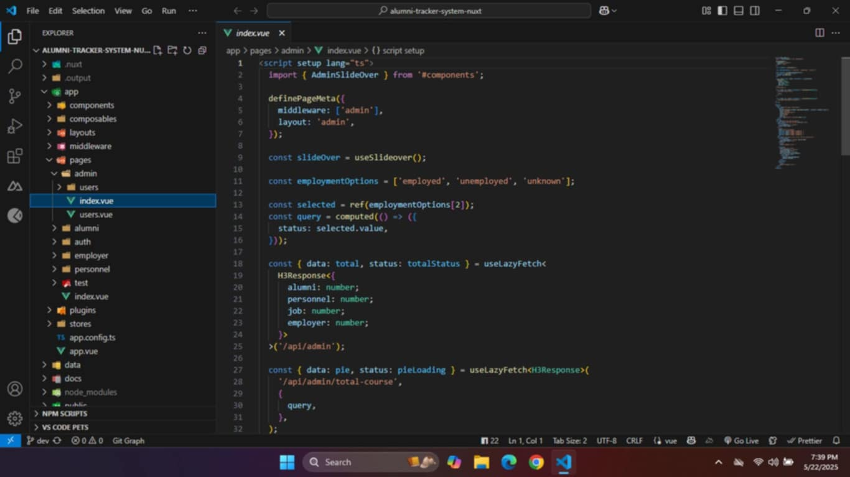

Visual Studio Codes

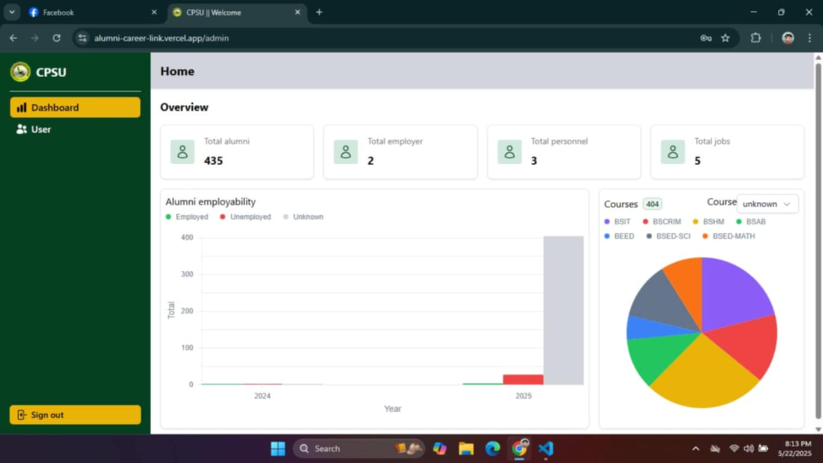

Admin Dashboard for Alumni Career Link: A Smart Tracking System Bridging Graduates and employment Opportunities

**Appendix D. Evaluation Tools**

**D.1. Questionnaire for School Personnel**

**Profile of the respondents:**

**NAME: (optional)____________________________**

**GENDER: ( ) Male ( ) Female**

**Position/Role: _______________**

**Years of Service at CPSU San Carlos: ____________**

**Department: ____________**

**Please rate the survey from 1-5: Please put a ( ✓ ) to your chosen number.**

***1 = Very Dissatisfied; 2 = Unsatisfied; 3 = Quite satisfied; 4 = Satisfied; 5 = Very Satisfied***

|  |  |  |  |  |  |
| --- | --- | --- | --- | --- | --- |
| **A. Responses of end-users on PIECES Software Evaluation of Performance throughout and response time.** | | | | | |
|  | **1** | **2** | **3** | **4** | **5** |
| 1. The system quickly processes alumni updates and employment verification. |  |  |  |  |  |
| 1. The chat feature performs reliably without delays. |  |  |  |  |  |
| 1. The system verifies employer legitimacy promptly. |  |  |  |  |  |
| **B. Responses of end-users on PIECES Software Evaluation in terms of Information Input, Output, and Data Storing** | | | | | |
|  | **1** | **2** | **3** | **4** | **5** |
| 1. The system accurately records alumni  employment data I update. |  |  |  |  |  |
| 1. The graphical employment trends provide clear, actionable insights. |  |  |  |  |  |
| 1. The chat feature delivers useful communication with alumni. |  |  |  |  |  |
| **D. Responses of end-users on PIECES Software Evaluation in terms of Control and security** | | | | | |
|  | **1** | **2** | **3** | **4** | **5** |
| 1. The system securely stores alumni data and employer information. |  |  |  |  |  |
| 1. The system restricts graphical trend data to authorized staff only. |  |  |  |  |  |
| 1. The system prevents unauthorized access to chats or records. |  |  |  |  |  |
| **E. Responses of end-users on PIECES Software Evaluation in terms of Efficiency** | | | | | |
|  | **1** | **2** | **3** | **4** | **5** |
| 1. The system simplifies updating alumni employment records. |  |  |  |  |  |
| 1. The system streamlines generating graphical employment trend reports. |  |  |  |  |  |
| 1. The group chat feature makes communicating with alumni efficient. |  |  |  |  |  |
| **F. Responses of end-users on PIECES Software Evaluation in terms of Service** | | | | | |
|  | **1** | **2** | **3** | **4** | **5** |
| 1. The system reliably supports managing alumni data and employer verification. |  |  |  |  |  |
| 1. The group chat feature enhances communication with alumni effectively. |  |  |  |  |  |
| 1. The system meets expectations for tracking trends and verifying employers. |  |  |  |  |  |

_______________________

Respondents Signature

**Appendix D. Evaluation Tools**

**D.2. Questionnaire for Students**

**Profile of the respondents:**

**NAME: (optional)____________________________**

**GENDER: ( ) Male ( ) Female**

**AGE: _____ Program/Degree Completed: _______________**

**Year of Graduation: ____________**

**Current Employment Status: () Employed () Unemployed () Self-Employed**

**Please rate the survey from 1-5: Please put a ( ✓ ) to your chosen number.**

***1 = Very Dissatisfied; 2 = Unsatisfied; 3 = Quite satisfied; 4 = Satisfied; 5 = Very Satisfied***

|  |  |  |  |  |  |
| --- | --- | --- | --- | --- | --- |
| **A. Responses of end-users on PIECES Software Evaluation of Performance throughout and response time.** | | | | | |
|  | **1** | **2** | **3** | **4** | **5** |
| 1. The web system quickly processes my employment information updates. |  |  |  |  |  |
| 1. The system allows me to apply for jobs efficiently, even outside my field. |  |  |  |  |  |
| 1. The system’s group chat feature works smoothly without delays. |  |  |  |  |  |
| **B. Responses of end-users on PIECES Software Evaluation in terms of Information Input, Output, and Data Storing** | | | | | |
|  | **1** | **2** | **3** | **4** | **5** |
| 1. The system accurately reflects my employment updates. |  |  |  |  |  |
| 1. The group chat feature delivers useful updates from CPSU staff. |  |  |  |  |  |
| 1. The system ensures my job applications are sent correctly to employers. |  |  |  |  |  |
| **C. Responses of end-users on PIECES Software Evaluation in terms of Control and security** | | | | | |
|  | **1** | **2** | **3** | **4** | **5** |
| 1. My personal and employment data are securely protected. |  |  |  |  |  |
| 1. I can control what information I share in chats or with employers. |  |  |  |  |  |
| 1. The system prevents unauthorized access to my profile. |  |  |  |  |  |
| **D. Responses of end-users on PIECES Software Evaluation in terms of Efficiency** | | | | | |
|  | **1** | **2** | **3** | **4** | **5** |
| 1. The system makes updating my employment info is quick and simple. |  |  |  |  |  |
| 1. The system streamlines applying to jobs, even outside my field. |  |  |  |  |  |
| 1. The system is compatible with various devices, including tablets and PCs. |  |  |  |  |  |
| **E. Responses of end-users on PIECES Software Evaluation in terms of Service** | | | | | |
|  | **1** | **2** | **3** | **4** | **5** |
| 1. The system is easy to use and navigate. |  |  |  |  |  |
| 1. It is always accessible without any issues. |  |  |  |  |  |
| 1. The system improves my overall experience as a CPSU alumnus. |  |  |  |  |  |

**_______________________**

Respondents Signature

**Appendix E. Evaluation Results**

**E.1. Evaluation Results of School Personnel**

|  |  |  |  |  |  |
| --- | --- | --- | --- | --- | --- |
| **A. Responses of end-users on PIECES Software Evaluation of Performance throughout and response time.** | | | | | |
|  | **1** | **2** | **3** | **4** | **5** |
| 1. 1. The system quickly processes alumni updates and employment verification. |  |  |  | 3 | 1 |
| 1. 2. The chat feature performs reliably without delays. |  |  |  | 2 | 2 |
| 1. 3. The system verifies employer legitimacy promptly. |  |  | 2 | 1 | 1 |
| **B. Responses of end-users on PIECES Software Evaluation in terms of Information Input, Output, and Data Storing.** | | | | | |
|  | **1** | **2** | **3** | **4** | **5** |
| 1. 1. The system accurately records alumni employment data I update. |  |  |  | 1 | 3 |
| 1. 2. The graphical employment trends provide clear, actionable insights. |  |  |  | 3 | 1 |
| 1. 3. The chat feature delivers useful communication with alumni. |  |  |  | 2 | 2 |
| **D. Responses of end-users on PIECES Software Evaluation in terms of Control and security.** | | | | | |
|  | **1** | **2** | **3** | **4** | **5** |
| 1. The system securely stores alumni data and employer information. |  |  |  | 2 | 2 |
| 1. The system restricts graphical trend data to authorized staff only. |  |  |  | 2 | 2 |
| 1. The system prevents unauthorized access to chats or records. |  |  |  | 2 | 2 |
| **E. Responses of end-users on PIECES Software Evaluation in terms of Efficiency** | | | | | |
|  | **1** | **2** | **3** | **4** | **5** |
| 1. The system simplifies updating alumni employment records. |  |  |  | 4 |  |
| 1. The system streamlines generating graphical employment trend reports. |  |  |  | 2 | 2 |
| 1. The group chat feature makes communicating with alumni efficient. |  |  |  | 2 | 2 |
| **F. Responses of end-users on PIECES Software Evaluation in terms of Service** | | | | | |
|  | **1** | **2** | **3** | **4** | **5** |
| 1. The system reliably supports managing alumni data and employer verification. |  |  |  | 2 | 2 |
| 1. The group chat feature enhances communication with alumni effectively. |  |  |  | 1 | 3 |
| 1. The system meets expectations for tracking trends and verifying employers. |  |  |  | 1 | 3 |

**E. 2. Evaluation Results of Students**

|  |  |  |  |  |  |
| --- | --- | --- | --- | --- | --- |
| **A. Responses of end-users on PIECES Software Evaluation of Performance throughout and response time.** | | | | | |
|  | **1** | **2** | **3** | **4** | **5** |
| 1. The web system quickly processes my employment information updates. |  |  |  |  | 4.50 |
| 1. The system allows me to apply for jobs efficiently, even outside my field. |  |  |  |  | 4.50 |
| 1. The system’s group chat feature works smoothly without delays. |  |  |  |  | 4.50 |
| **B. Responses of end-users on PIECES Software Evaluation in terms of Information Input, Output, and Data Storing** | | | | | |
|  | **1** | **2** | **3** | **4** | **5** |
| 1. The system accurately reflects my employment updates. |  |  |  |  | 4.47 |
| 1. The group chat feature delivers useful updates from CPSU staff. |  |  |  |  | 4.57 |
| 1. The system ensures my job applications are sent correctly to employers. |  |  |  |  | 4.55 |
| **C. Responses of end-users on PIECES Software Evaluation in terms of Control and security** | | | | | |
|  | **1** | **2** | **3** | **4** | **5** |
| 1. My personal and employment data are securely protected. |  |  |  |  | 4.57 |
| 1. I can control what information I share in chats or with employers. |  |  |  |  | 4.54 |
| 1. The system prevents unauthorized access to my profile. |  |  |  |  | 4.52 |
| **D. Responses of end-users on PIECES Software Evaluation in terms of Efficiency** | | | | | |
|  | **1** | **2** | **3** | **4** | **5** |
| 1. The system makes updating my employment info is quick and simple. |  |  |  |  | 4.49 |
| 1. The system streamlines applying to jobs, even outside my field. |  |  |  |  | 4.55 |
| 1. The system is compatible with various devices, including tablets and PCs. |  |  |  |  | 4.57 |
| **E. Responses of end-users on PIECES Software Evaluation in terms of Service** | | | | | |
|  | **1** | **2** | **3** | **4** | **5** |
| 1. The system is easy to use and navigate. |  |  |  |  | 4.56 |
| 1. It is always accessible without any issues. |  |  |  |  | 4.52 |
| 1. The system improves my overall experience as a CPSU alumnus. |  |  |  |  | 4.60 |

**Appendix F. Photos during the Conduct of Evaluation with the System Beneficiaries**

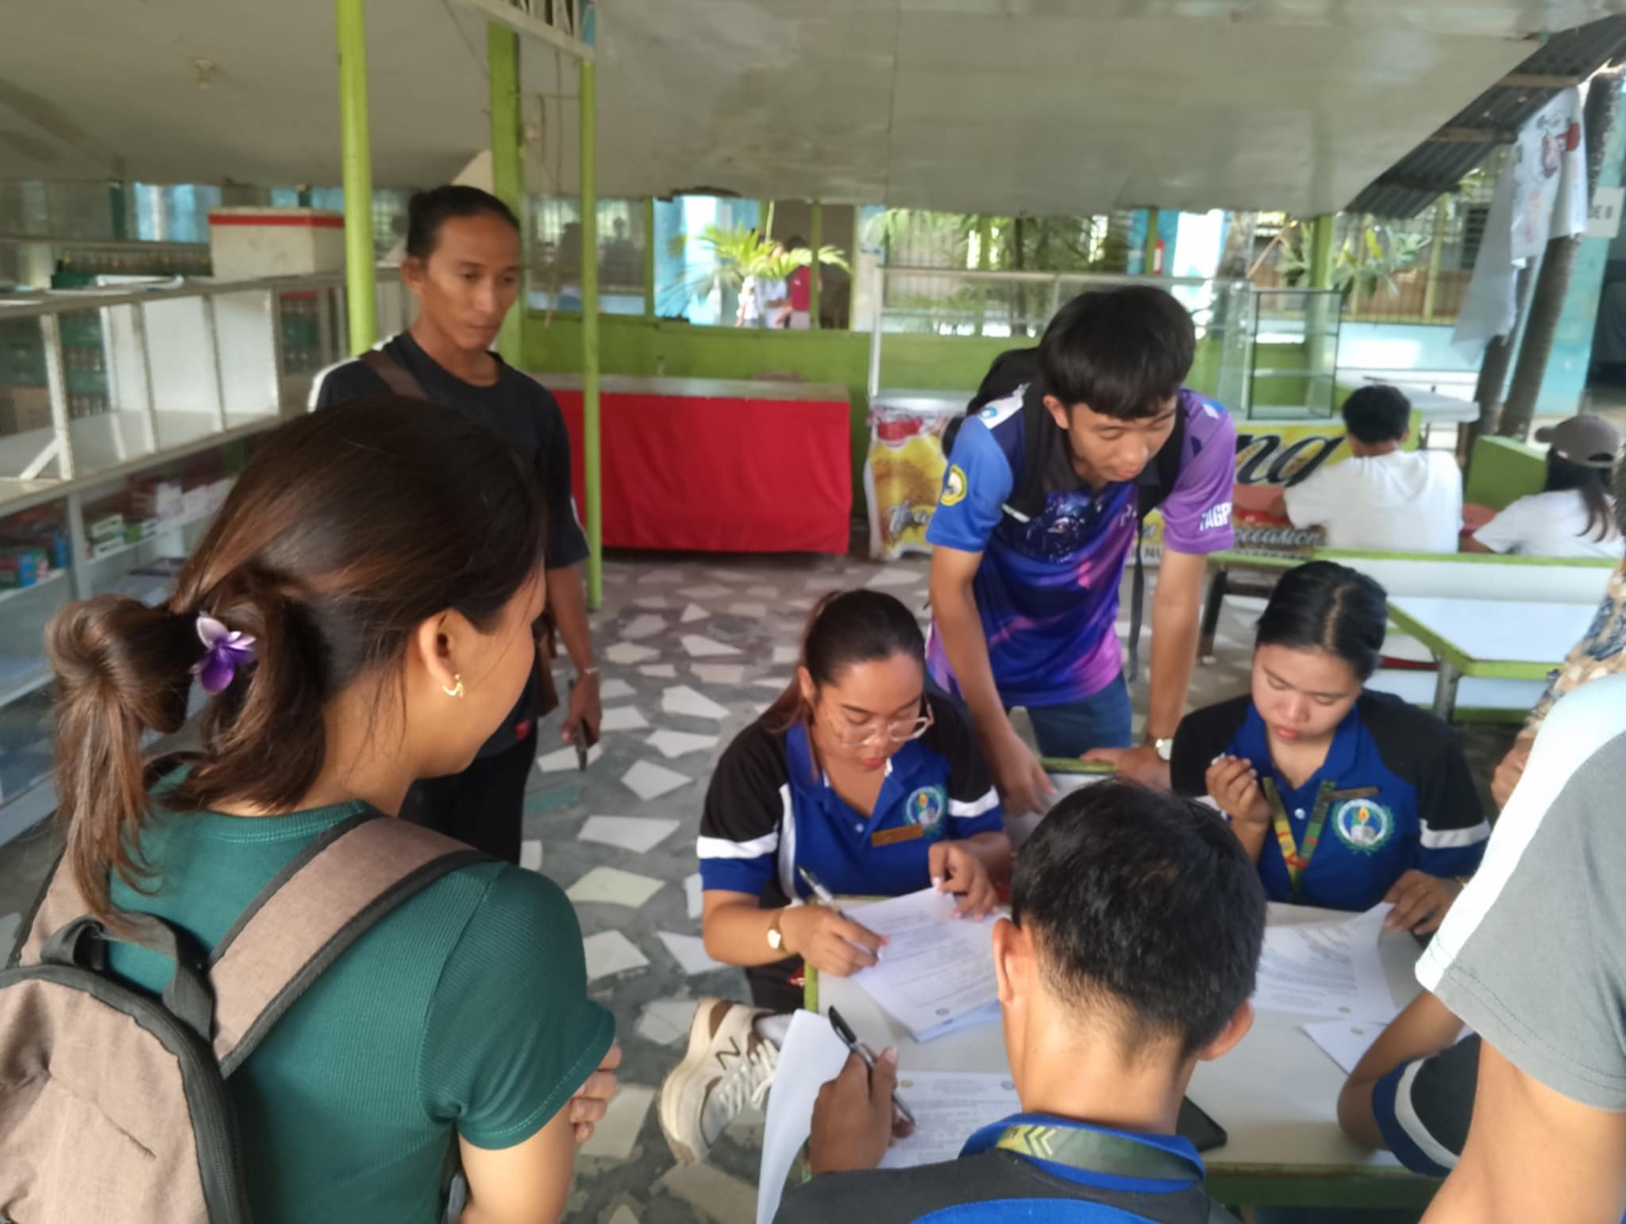

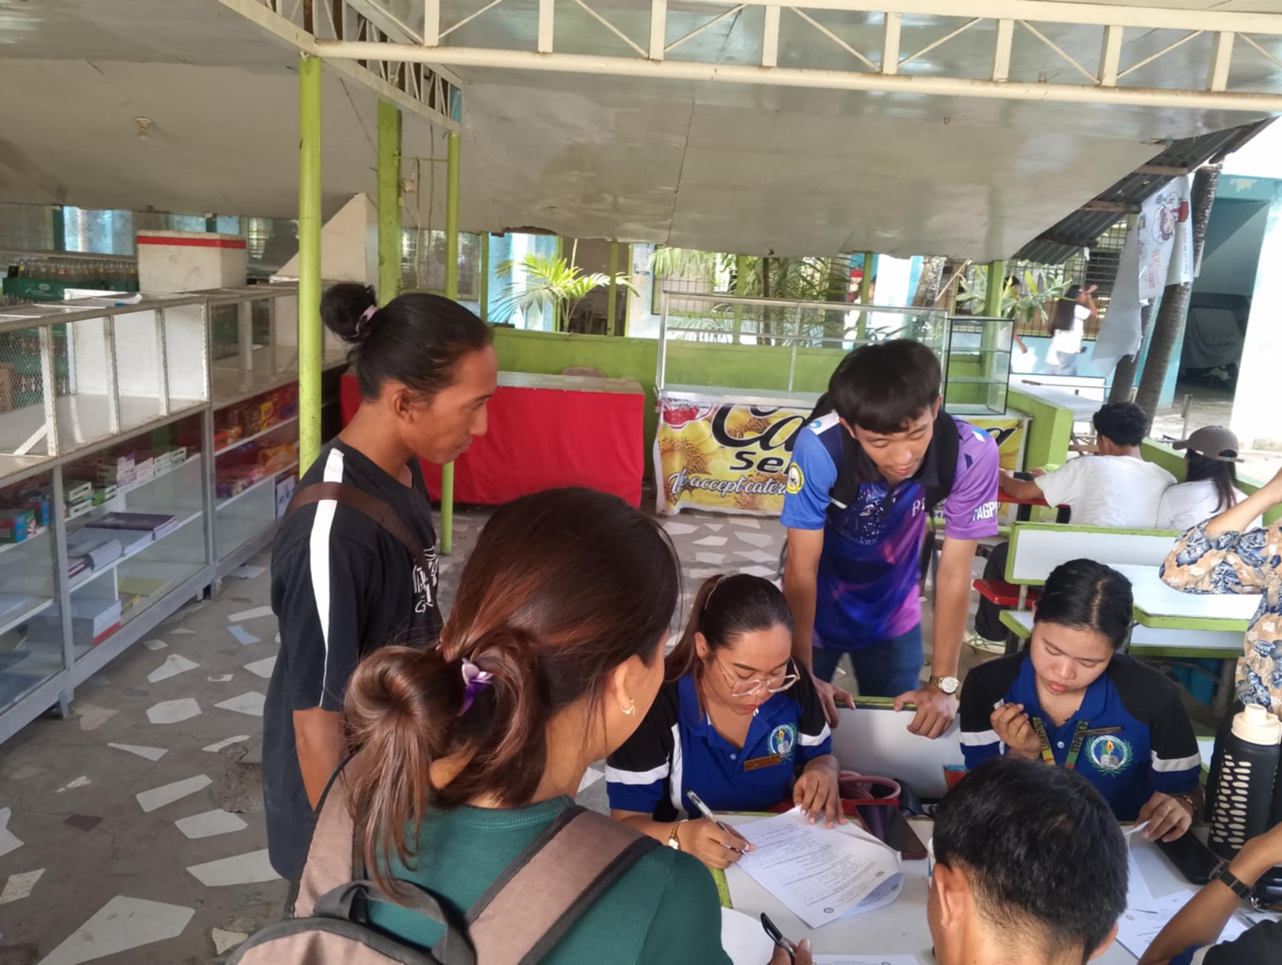

The photos above show BSED students evaluating the Alumni Career Link System: A Smart Tracking System Bridging Graduates and Employment Opportunities.

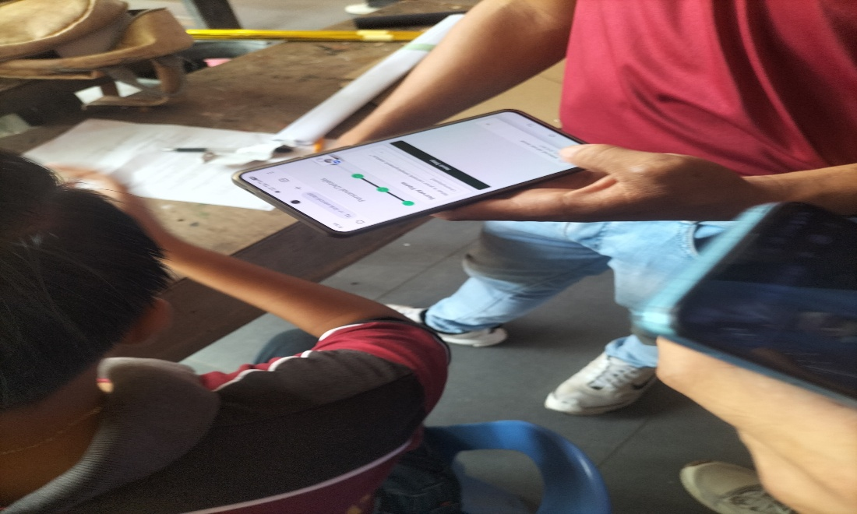

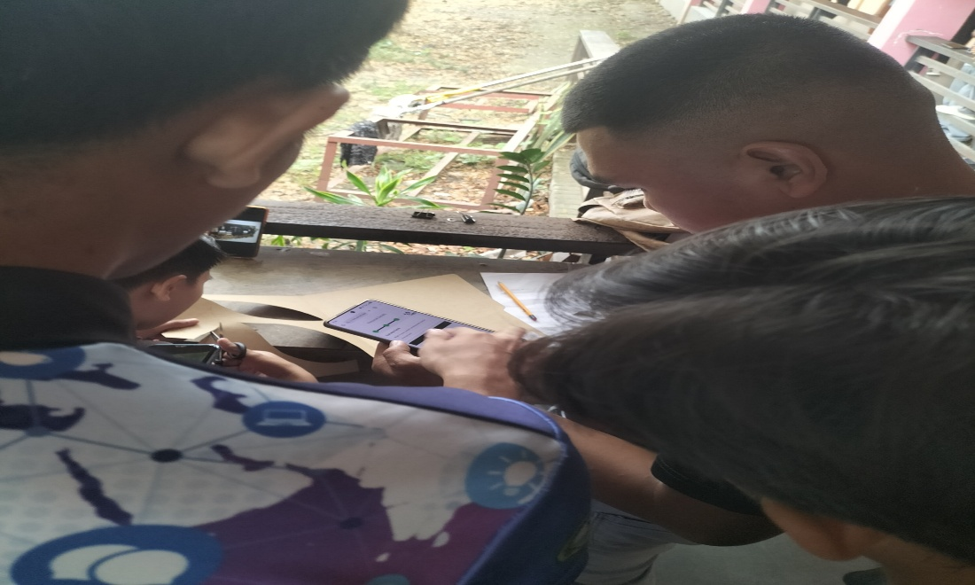

The photos above show the BSCRIM students, evaluating the Alumni Career Link System: A Smart Tracking System Bridging Graduates and Employment Opportunities

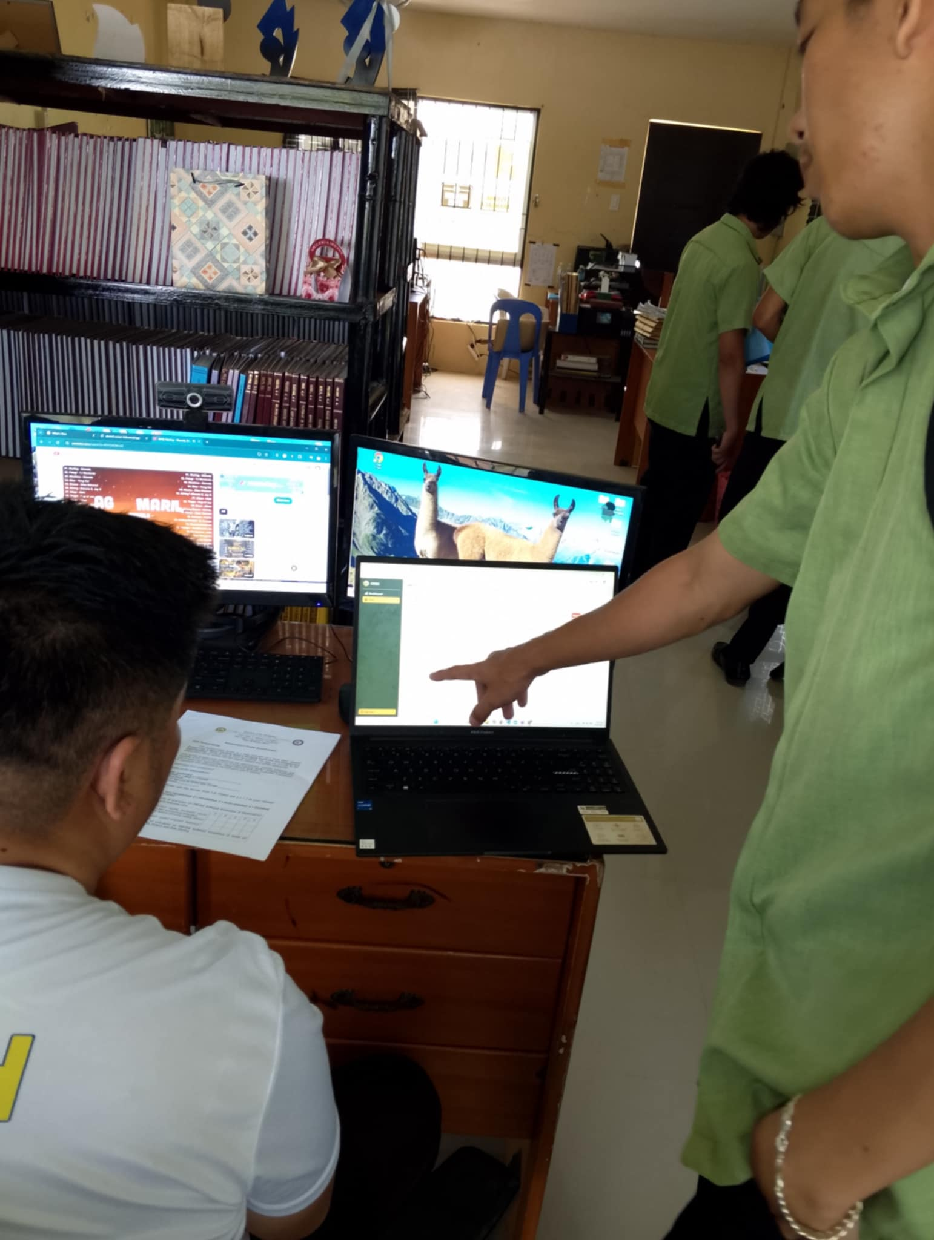

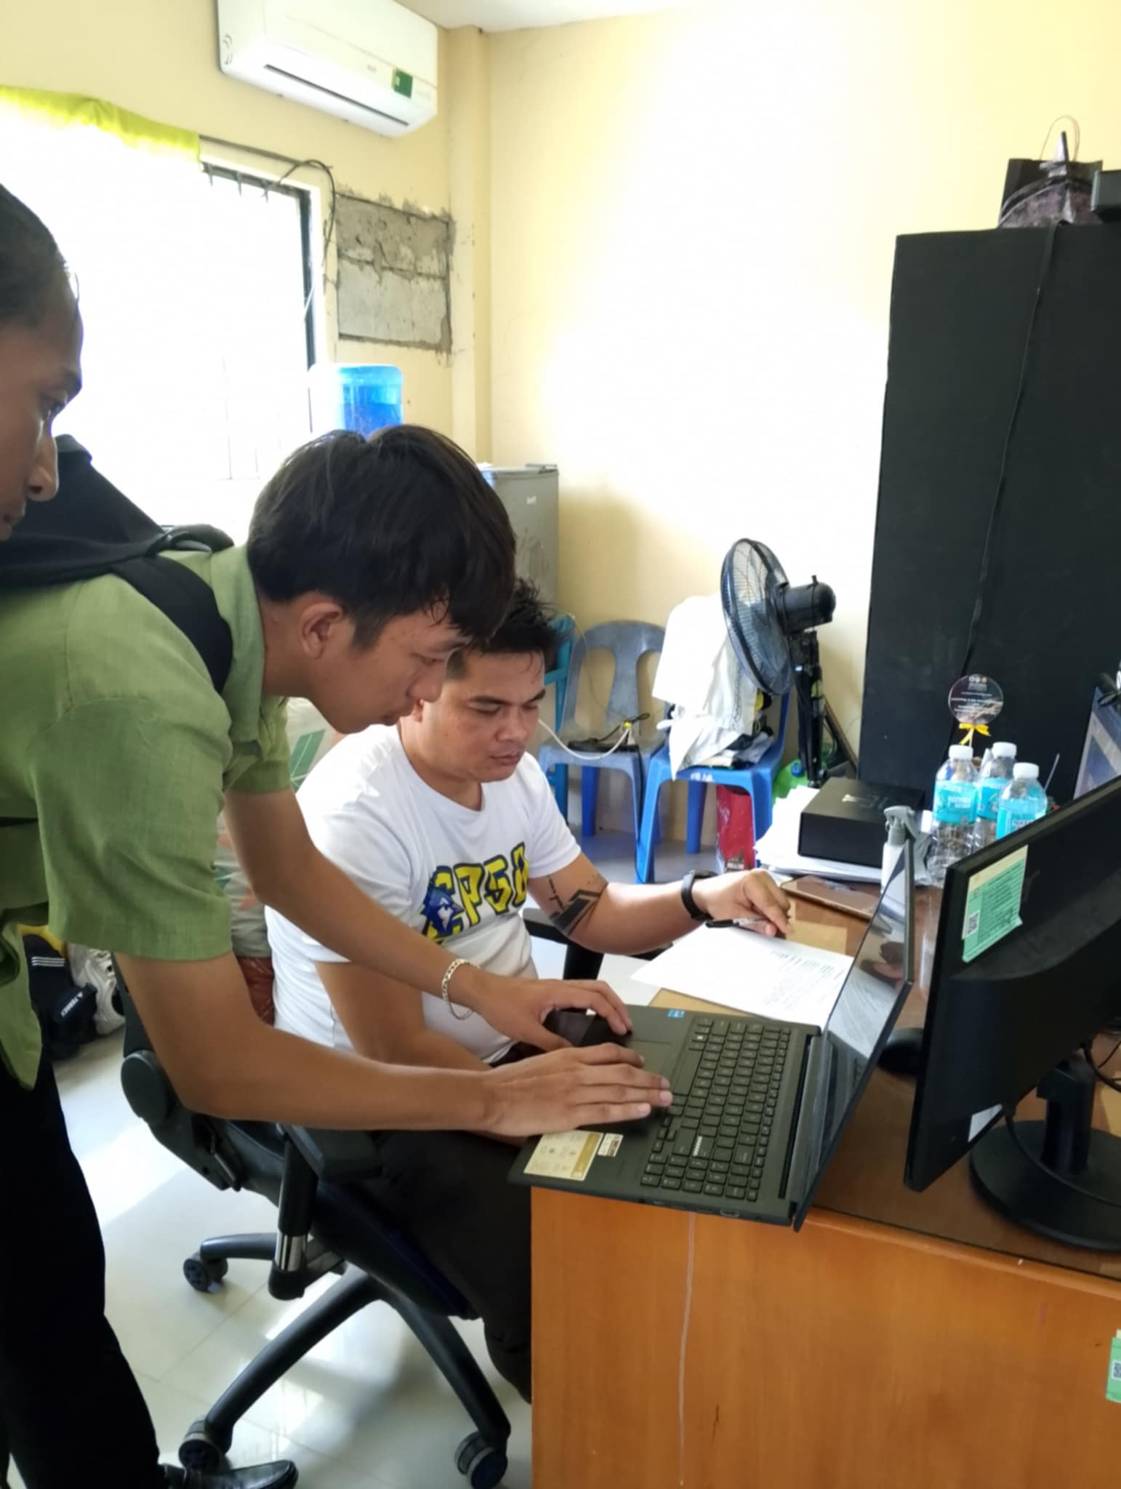

The photos above show the Research Office at CPSU San Carlos Campus evaluating the Alumni Career Link System: A Smart Tracking System Bridging Graduates and Employment Opportunities.

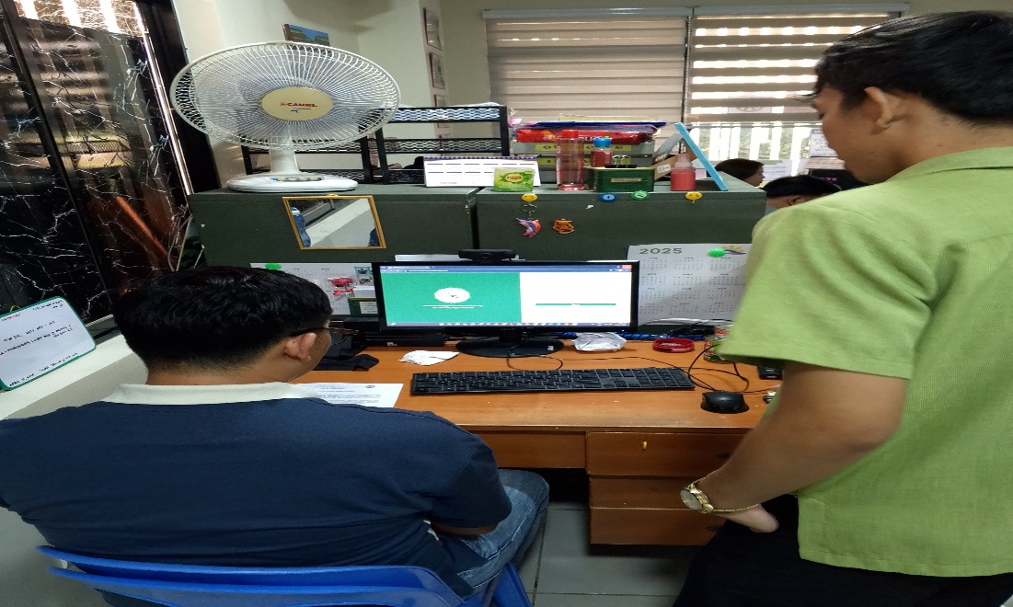

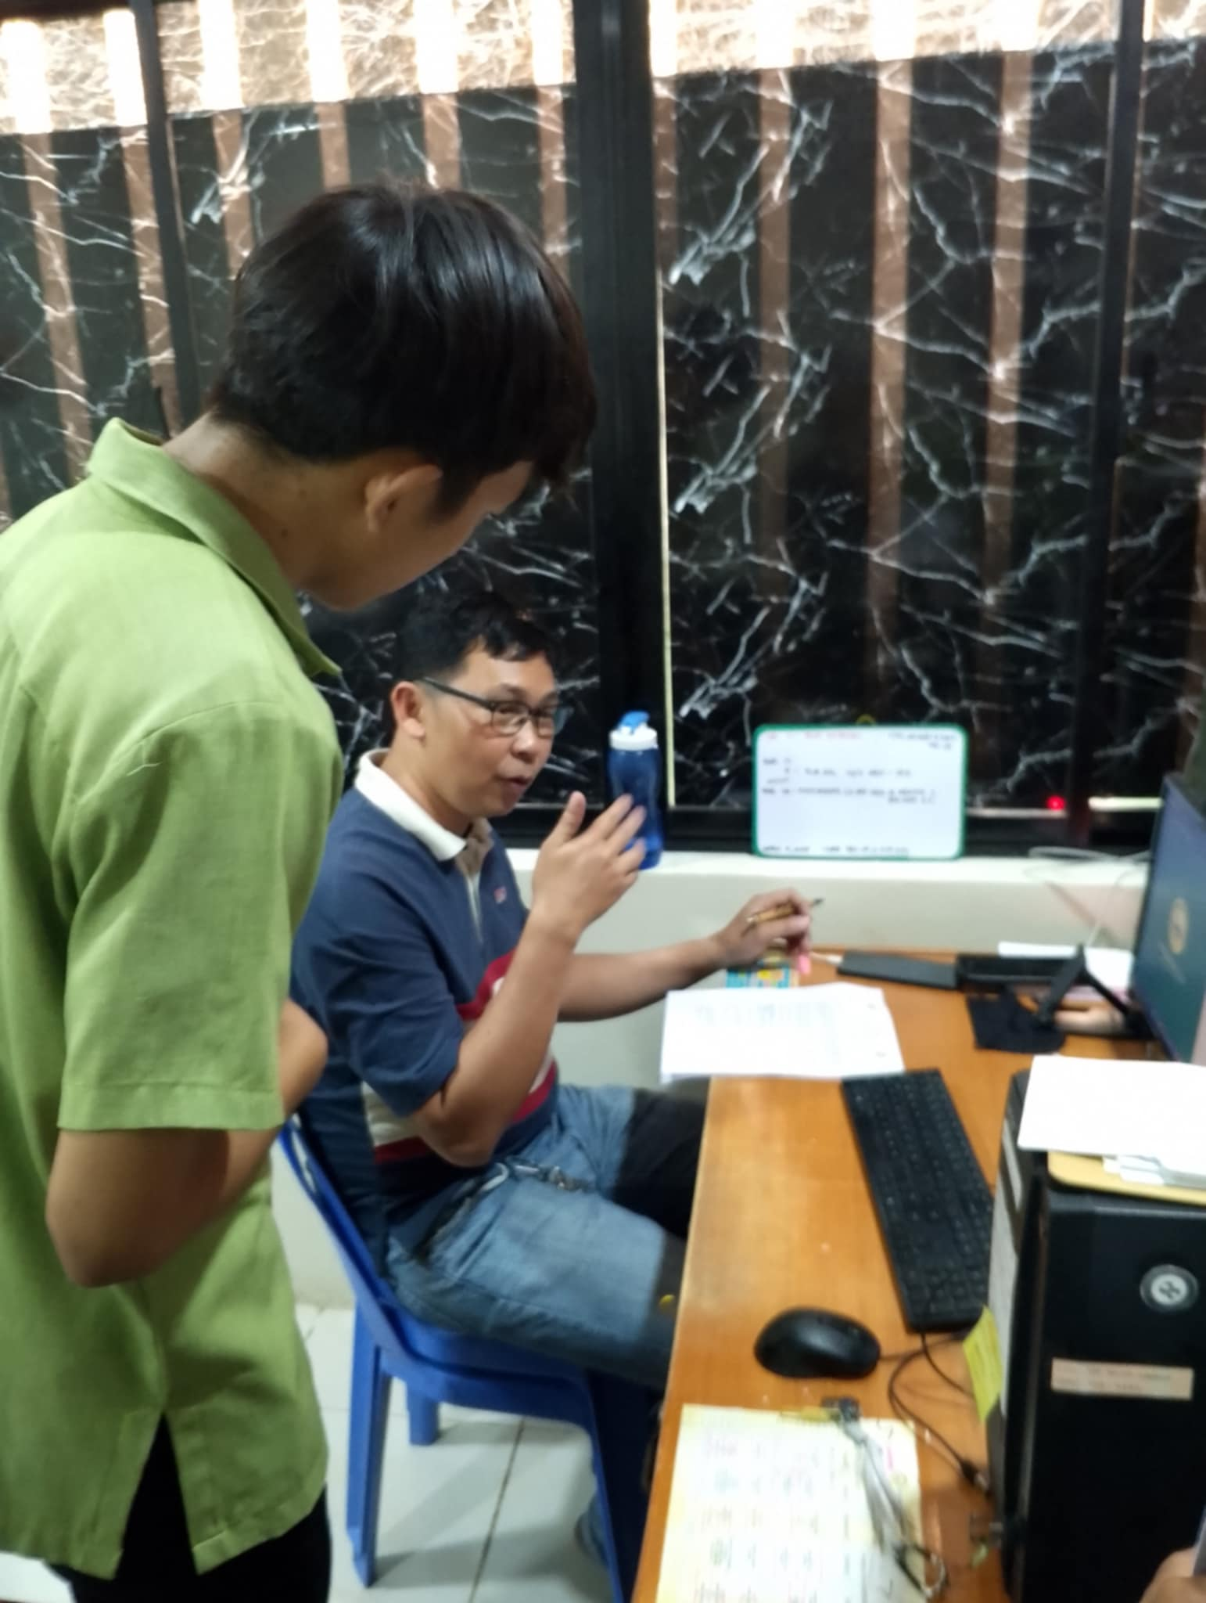

The photos above show the other staff of CPSU San Carlos Campus evaluating the Alumni Career Link System: A Smart Tracking System Bridging Graduates and Employment Opportunities

**Appendix G. Screen Layouts**



Admin Dashboard

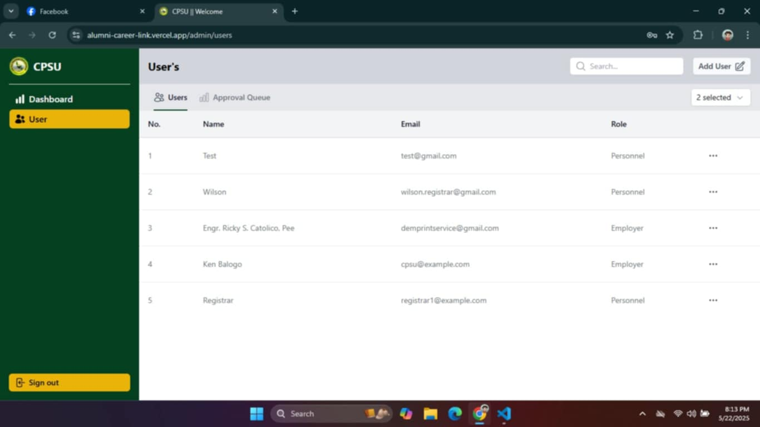

Admin Selected Role

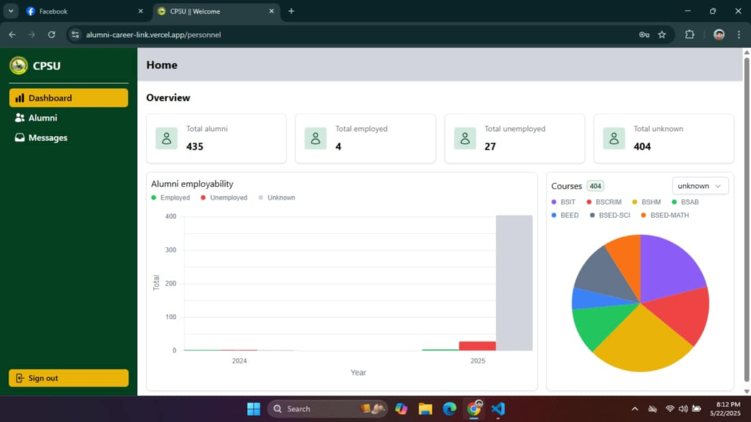

School Personnel Dashboard

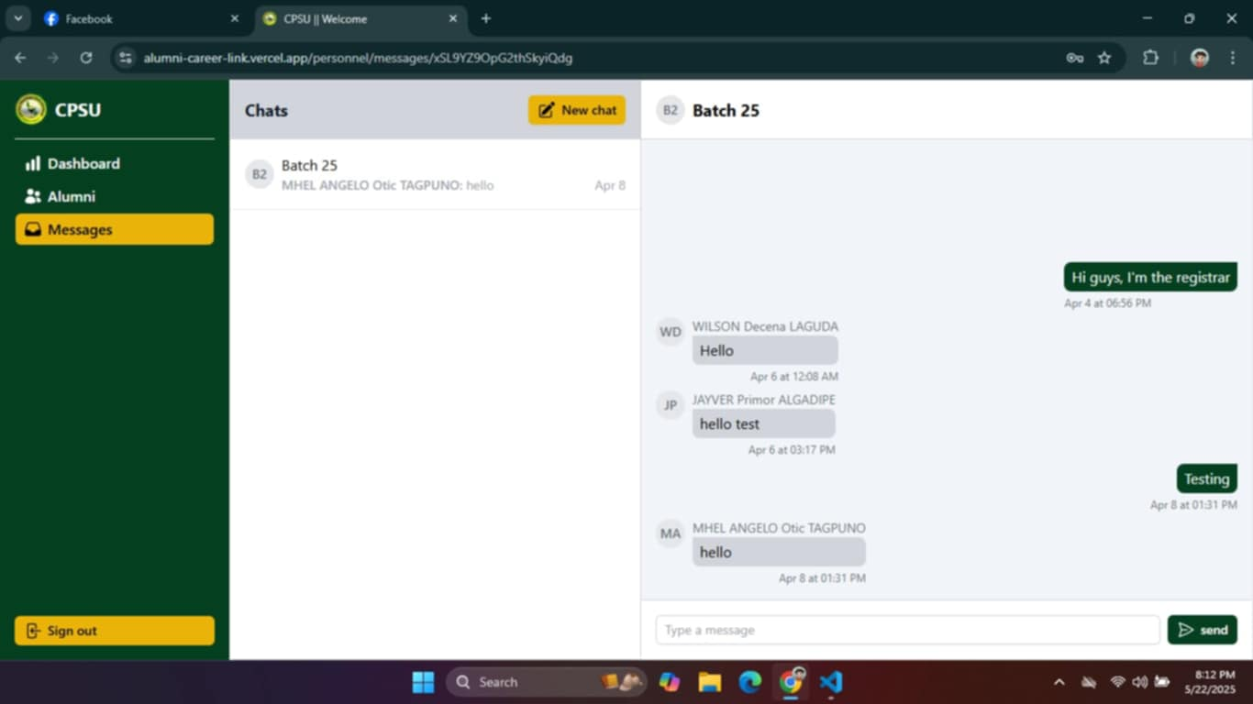

School Personnel when creating a Group Chats

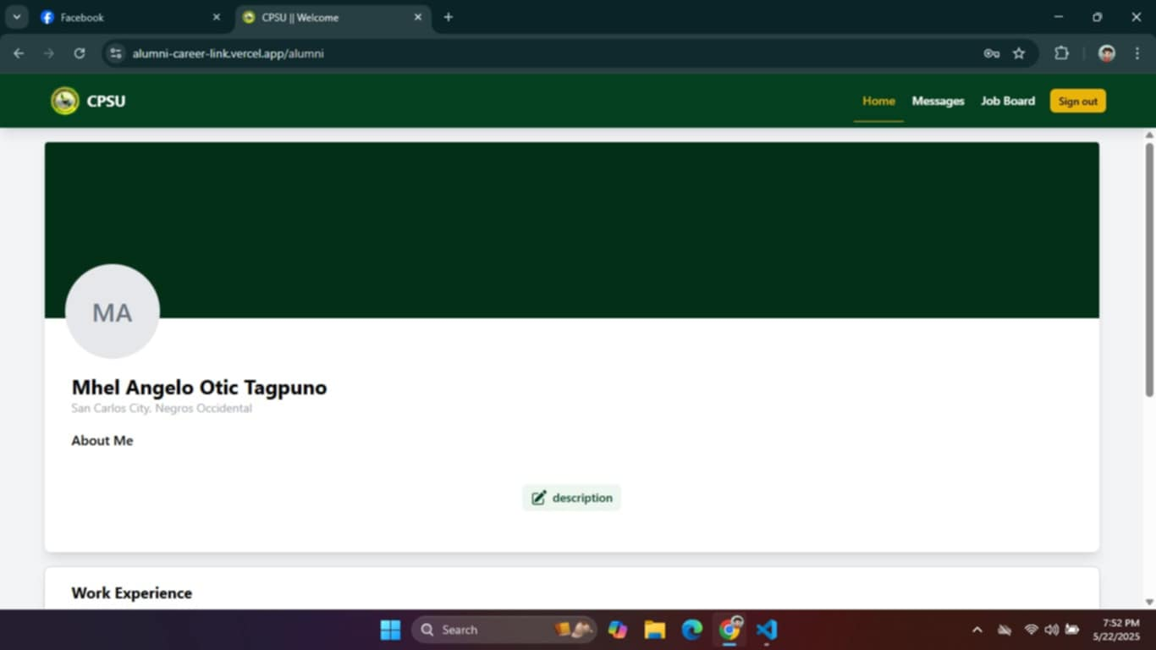

Alumni’s Profiles

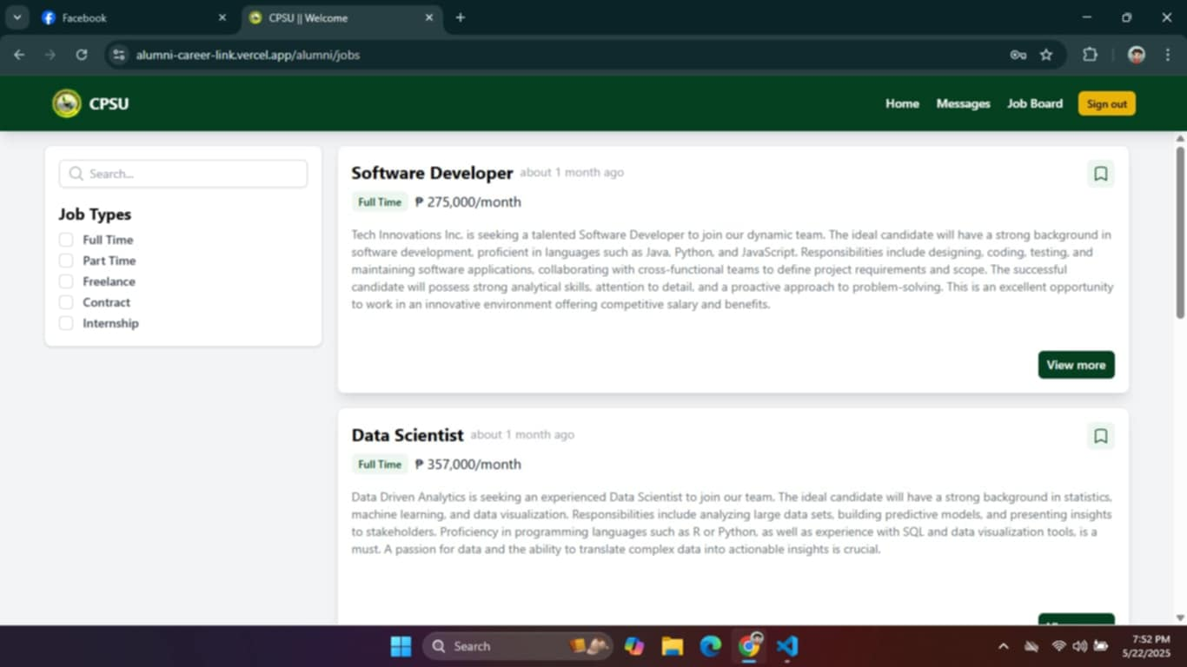

Alumni Job Board

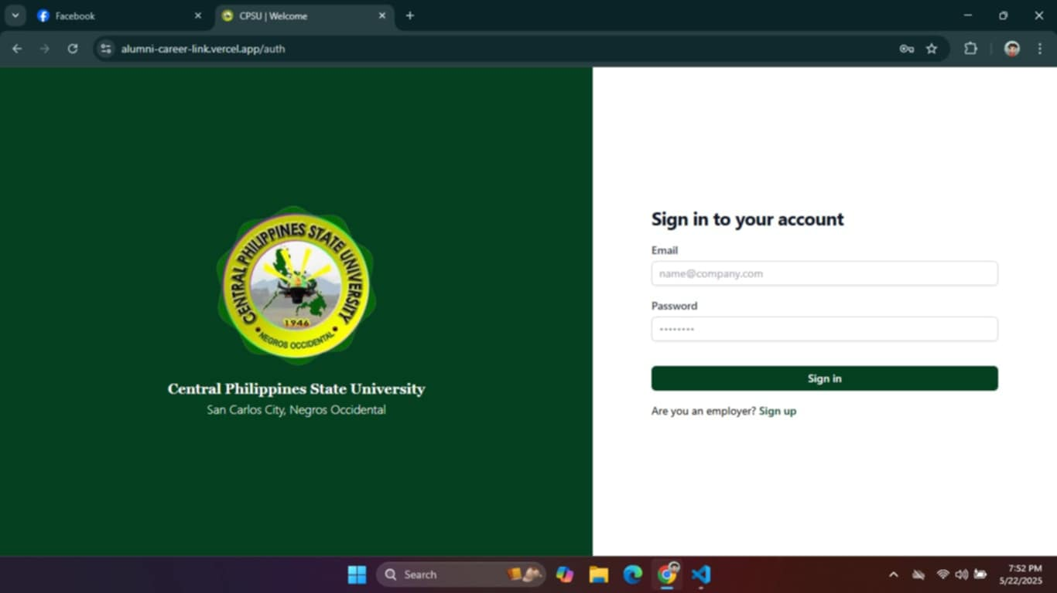

Sign Up for Users

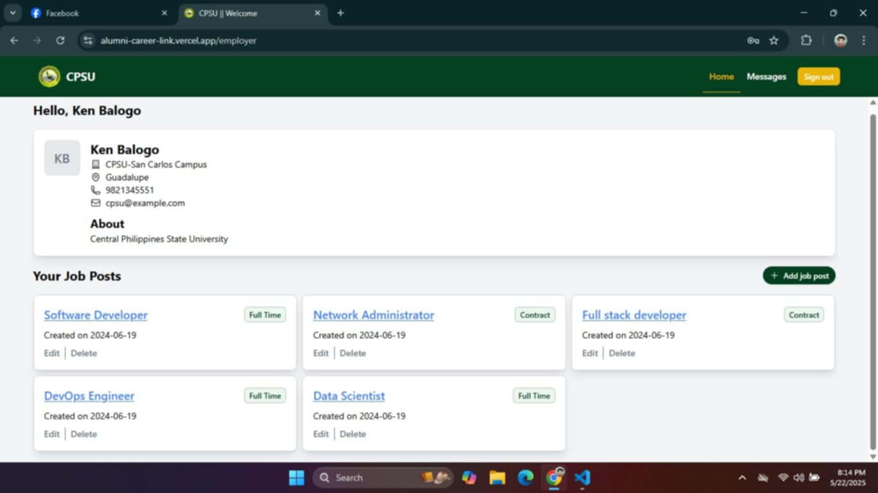

Employer’s Profile

**Appendix H. Source Code**

<script setup lang="ts">

  import type { FormError } from '#ui/types';

  import type { Auth } from 'firebase/auth';

  const creds = reactive({

    email: '',

    password: '',

  });

  const auth = useFirebaseAuth();

  const validate = (state: any): FormError[] => {

    const errors = [];

    if (!state.email) errors.push({ path: 'email', message: 'Required' });

    if (!state.password) errors.push({ path: 'password', message: 'Required' });

    return errors;

  };

  const { handleLogin, isLoading, error } = useAuth();

  watch(error, () => console.log(error.value));

</script>

<template>

  <div class="flex h-screen w-full">

    <div

      class="h-full flex-1 justify-center items-center hidden bg-primary-500 gap-4 flex-col text-white lg:flex">

      <NuxtImg

        src="/cpsu-logo.png"

        class="w-52 h-52"

        preload />

      <div class="flex flex-col items-center justify-center">

        <label class="text-lg font-bold font-serif"

          >Central Philippines State University</label

        >

        <span class="font-thin">San Carlos City, Negros Occidental</span>

      </div>

    </div>

    <div

      class="flex justify-center items-center h-full w-full px-4 xl:px-16 lg:w-[600px]">

      <div

        class="flex flex-col w-full max-w-md gap-4 border p-8 rounded-lg shadow-lg lg:border-none lg:shadow-none lg:p-0">

        <div class="flex gap-2 items-center lg:hidden">

          <NuxtImg

            src="/cpsu-logo.png"

            height="44"

            width="44"

            preload />

          <label class="font-bold">CPSU</label>

        </div>

        <h1

          class="text-xl font-bold leading-tight tracking-tight text-gray-900 md:text-2xl dark:text-white">

          Sign in to your account

        </h1>

        <UAlert

          :title="error"

          color="red"

          variant="subtle"

          v-show="error"

          :ui="{ padding: 'p-2' }"

          class="text-center" />

        <UForm

          :validate="validate"

          :state="creds"

          class="flex flex-col gap-4"

          @submit.prevent="

            handleLogin(auth as Auth, creds.email, creds.password)

          ">

          <UFormGroup label="Email">

            <UInput

              autocomplete="username"

              type="email"

              v-model="creds.email"

              name="email"

              id="email"

              placeholder="name@company.com"

              required />

          </UFormGroup>

          <UFormGroup label="Password">

            <UInput

              autocomplete="current-password"

              type="password"

              v-model="creds.password"

              name="password"

              id="password"

              placeholder="••••••••"

              required />

          </UFormGroup>

          <UButton

            type="submit"

            block

            class="mt-4"

            label="Sign in"

            :loading="isLoading" />

          <p class="text-sm">

            Are you an employer?

            <NuxtLink

              to="/auth/signup"

              class="hover:underline text-primary-500 font-semibold"

              >Sign up</NuxtLink

            >

          </p>

        </UForm>

      </div>

    </div>

  </div>

</template>

</div> </div> --> </div> </template>

**BIOGRAPHICAL SKETCH**

**PERSONAL INFORMATION**

Name : Mhel Angelo O. Tagpuno

Nickname : Mel

Date of Birth : November 2, 2002

Place of Birth : Tacloban City

Address : Ylagan Ext., Brgy V, San Carlos City, Neg. Occ.

Father’s Name : Angelito M. Tagpuno

Mother’s Name : Melinda O. Tagpuno

E-mail : [tagpuno619@gmail.com](mailto:tagpuno619@gmail.com)

**EDUCATIONAL BACKGROUND**

**Educational School Last Attended Year Graduated**

Elementary Tandang Sora Elementary School 2014-2015

San Carlos City

Secondary Tañon College 2020-2021

San Carlos City Neg. Occ.

Tertiary Central Philippines State University 2024-2025

San Carlos City Neg. Occ.

Course Bachelor of Science in Information Technology

**AFFILIATION IN ORGANIZATIONS**

**Organization Position Year**

PSITS Member 2021-2025

**BIOGRAPHICAL SKETCH**

**PERSONAL INFORMATION**

Name : Ilyn E. Inodeo

Nickname : Ai

Date of Birth : November 28, 2002

Place of Birth : Vallehermoso Negros Oriental

Address : Sitio Lumboy, Brgy. Malangsa, Vallehermoso

Negros Oriental

Father’s Name : Carlito C. Inodeo

Mother’s Name : Rufina E. Inodeo

E-mail : [ilyninodeo376@gmail.com](mailto:ilyninodeo376@gmail.com)

**EDUCATIONAL BACKGROUND**

**Educational School Last Attended Year Graduated**

Elementary Malangsa Elementary School 2014-2015

Vallehermoso Neg. Or.

Secondary Vallehermoso National High School 2020-2021

Vallehermoso Neg. Or.

Tertiary Central Philippines State University 2024-2025

San Carlos City Neg. Occ.

Course Bachelor of Science in Information Technology

**AFFILIATION IN ORGANIZATIONS**

**Organization Position Year**

PSITS Member 2021-2025

**BIOGRAPHICAL SKETCH**

**PERSONAL INFORMATION**

Name : Vesper Idyl L. Vencing

Nickname : Idyl

Date of Birth : August 8, 1999

Place of Birth : Poblacion, Vallehermoso Negros Oriental

Address : Sitio Trangka Uno Brgy. Tagbino Vallehermoso

Negros Oriental

Father’s Name : Ricardo V. Vencing

Mother’s Name : Jonielyn C. Vencing

E-mail : [vencingvesperidyl@gmail.com](mailto:vencingvesperidyl@gmail.com)

**EDUCATIONAL BACKGROUND**

**Educational School Last Attended Year Graduated**

Elementary Dumlog Elementary School 2010-2011

Dumlog Toledo City, Cebu

Secondary Tagbino National High School 2014-2015

Vallehermoso Negros Oriental.

Tertiary Central Philippines State University 2024-2025

San Carlos City Neg. Occ.

Course Bachelor of Science in Information Technology

**AFFILIATION IN ORGANIZATIONS**

**Organization Position Year**

PSITS Member 2021-2025